Name: ____________________________ Surname: ____________________________ N^{ber}: ____ Grade/Class: _____
Assessment: _____________________________  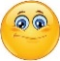 | Date: ___________________________________________________
 | Teacher’s signature:  ___________________________ | Parent’s signature:  ___________________________

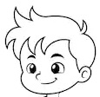
Label the picture. Then colour.

J __ __ k __ __
J __ __ p __ __

T __ o __ s __ __ s

S __ __ e __
S __ __ k __

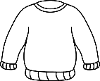
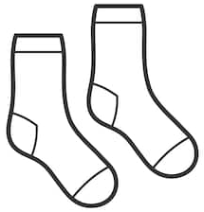
The is red.
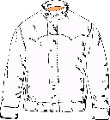
The are grey.
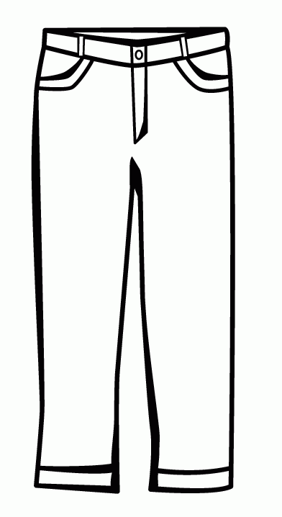
The is yellow.
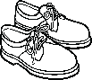
The are green.
The are brown.

ANSWER KEY

Jacket
Jumper

Trousers

Shoes
Socks

