Name: ____________________________ Surname: ____________________________ N^{ber}: ____ Grade/Class: _____
Assessment: _____________________________ | Date: ___________________________________________________
 | Teacher’s signature:  ___________________________ | Parent’s signature:  ___________________________

Find and label the pictures

JACKETYFEPSOCKSBAIBGJUMPERMONUTROUSERSLOPUSHOESGASEPYJAMAS

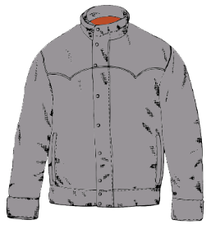
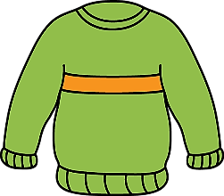
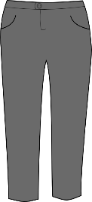

- ____________________ b) ____________________ c) ____________________
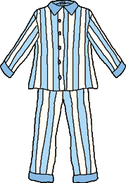

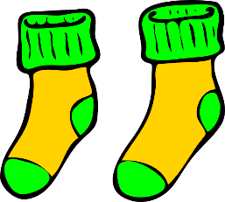
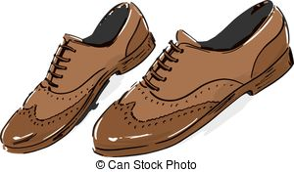

- ____________________ e) ____________________ f) ____________________

ANSWER KEY

- Jumper
- Trousers
- Jacket
- Pyjamas
- Socks
- Shoes

