Name: ____________________________ Surname: ____________________________ N^{ber}: ____ Grade/Class: _____
Assessment: _____________________________ | Date: ___________________________________________________
 | Teacher’s signature:  ___________________________ | Parent’s signature:  ___________________________

- Read and complete.

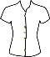
It’s sunny and warm.
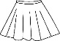
Put on your wh__ t __ b__ __ u __ e
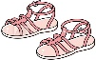
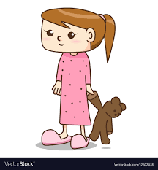
your p__ r __ l __ s__ i __ t,
and your p__ __ k s__n__a__ s.

- What colour are the clothes? Find, colour and write.
- ____________ ____________
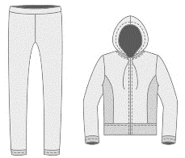
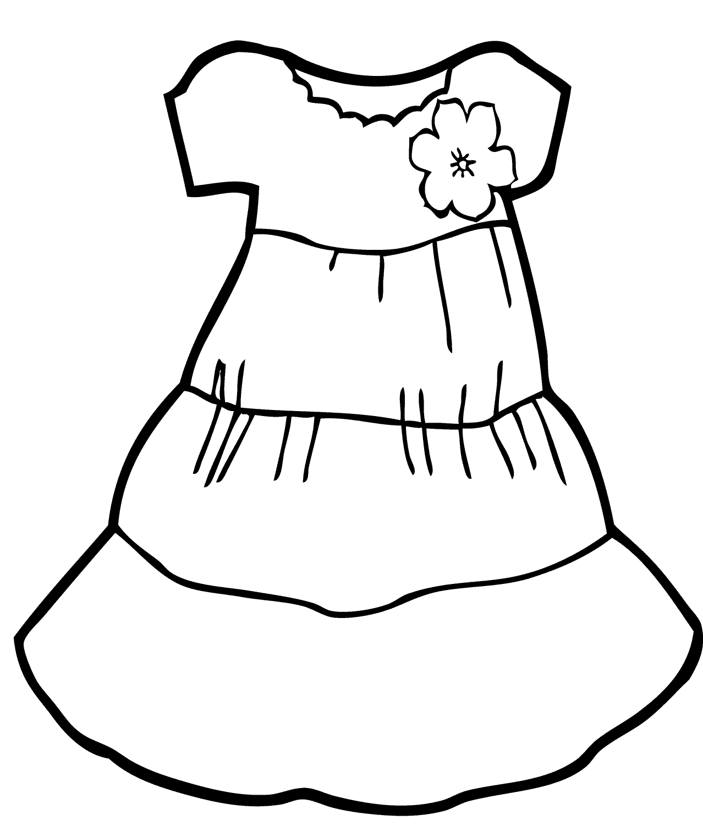
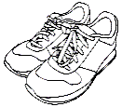
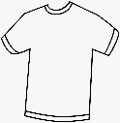
- A ____________ ___________
- ____________ ____________
- A ___________ ____________
- A ____________ ___________

ANSWER KEY

EXERCISE 1

white blouse
purple skirt
pink sandals

EXERCISE 2

Green shorts
A blue T-shirt
A yellow tracksuit
Green trainers
A purple dress

