|  |  |  |
| --- | --- | --- |
| **Name:** ____________________________ **Surname:** ____________________________ **Nber: ____ Grade/Class:** _____ | | |
| **Assessment:** _____________________________ | **Date:** ___________________________________________________ | |
| **Teacher’s signature:**  **___________________________** | **Parent’s signature:**  **___________________________** |

**Look and complete the crossword.**

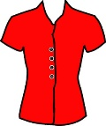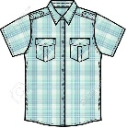

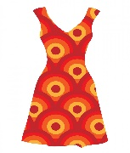

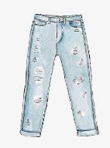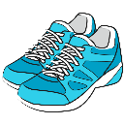

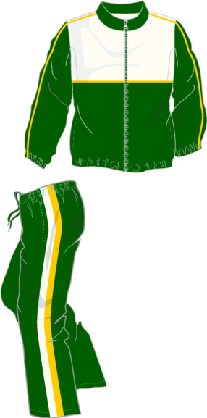

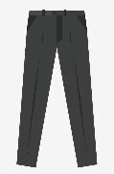****

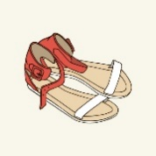

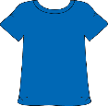

**ANSWER KEY**

|  |  |  |  |  |  |  |  |  |  |  |  |  |  |  |  |  |  |  |
| --- | --- | --- | --- | --- | --- | --- | --- | --- | --- | --- | --- | --- | --- | --- | --- | --- | --- | --- |
|  | S |  |  |  |  | B |  |  |  |  |  |  |  |  |  |  |  |  |
|  | h |  |  |  |  | l |  |  |  |  |  |  |  |  |  |  |  |  |
|  | i |  |  |  |  | o |  |  |  |  |  |  |  |  |  |  |  |  |
| T | r | a | c | k | s | u | i | T |  |  |  | D |  |  |  | J |  |  |
|  | t |  |  |  |  | s |  | r |  |  | T | r | o | u | s | e | r | s |
|  |  |  |  |  |  | e |  | a |  |  |  | e |  |  |  | a |  |  |
|  |  |  |  |  |  |  |  | i |  |  |  | s |  |  |  | n |  |  |
|  |  |  |  |  |  | S | a | n | d | a | l | s |  |  |  | s |  |  |
|  |  |  |  |  |  |  |  | e |  |  |  |  |  |  |  |  |  |  |
|  |  |  | T | - | s | h | i | r | t |  |  |  |  |  |  |  |  |  |
|  |  |  |  |  |  |  |  | s |  |  |  |  |  |  |  |  |  |  |