Name: ____________________________ Surname: ____________________________ N^{ber}: ____ Grade/Class: _____
Assessment: _____________________________  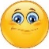 | Date: ___________________________________________________
 | Teacher’s signature:  ___________________________ | Parent’s signature:  ___________________________

- Read and circle the correct words.
I’m wearing my pink swimsuit / skirt,
my pink sunglasses / hat
and my green sandals / flip flops.

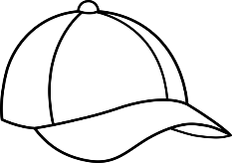
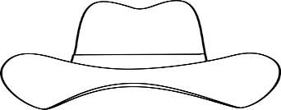
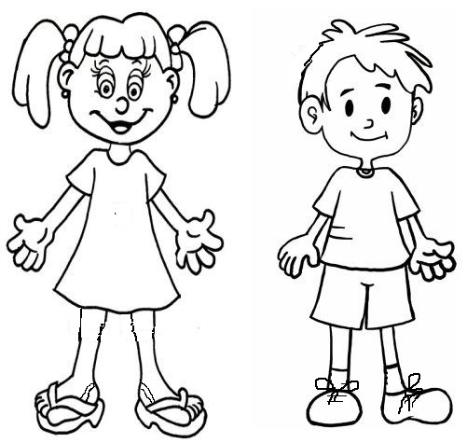
- Read, colour and write.
A brown c __ __
A red T-__h __ r __
Orange s__ o __ t __
Blue t__ a __ n __ __ s
Purple s__ n __ a __ s
A red d__ e __ __
A yellow h__ __

ANSWER KEY

EXERCISE 1

Swimsuit
Sunglasses
Flip flops

EXERCISE 2

A yellow hat
A red dress
Purple sandals
A brown cap
A red T-shirt
Orange shorts
Blue trainers

