Name: ____________________________ Surname: ____________________________ N^{ber}: ____ Grade/Class: _____
Assessment: _____________________________ | Date: ___________________________________________________
 | Teacher’s signature:  ___________________________ | Parent’s signature:  ___________________________

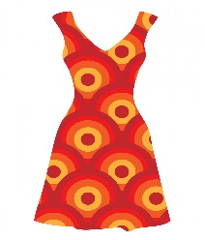
- Write and match.
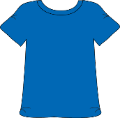
- D __ e __ s
- B __ o __ s __
- H __ __
- C __ __
- S k __ __t
- T-S__ i__ t
- S __ __ d __ l __
- S h __ __ t
- S h __ r __ s
- T __ a __ n __ __ s
- S __ __ m s __ __ t
- F__ i __ f__o __ s
- S __ __ g __ a __ s __ s

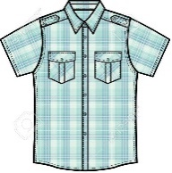
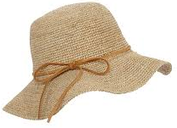

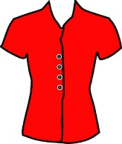
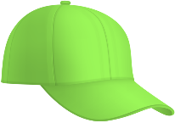

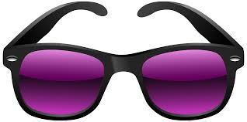
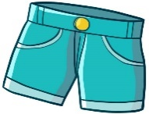

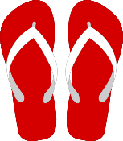
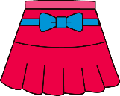

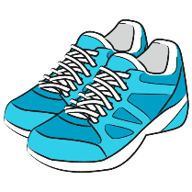

2) Answer.
In summer, what do you like wearing? I like wearing __________________________________________
ANSWER KEY

EXERCISE 1

- dress
- blouse
- hat
- cap
- skirt
- T-shirt
- Sandals
- Shirt
- Shorts
- Trainers
- Swimsuit
- Flip flops
- Sunglasses

EXERCISE 2
Suggestion:
I like wearing shorts, t-shirts and sandals.

