Name: ____________________________ Surname: ____________________________ N^{ber}: ____ Grade/Class: _____
Assessment: _____________________________ | Date: ___________________________________________________
 | Teacher’s signature:  ___________________________ | Parent’s signature:  ___________________________

Fill in the gaps and colour.
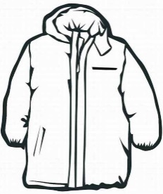
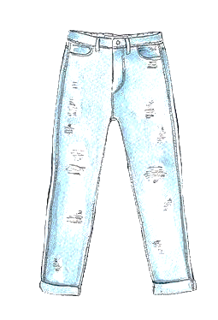
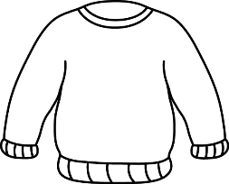

A p__ __ p__e j__ m __ __ r
A g __ e __ n c__ __ t
B__ u __ j__ __ n __

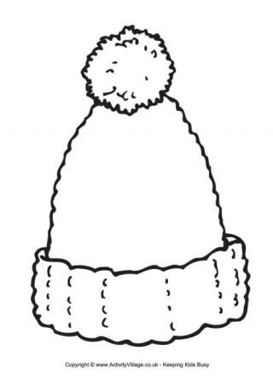
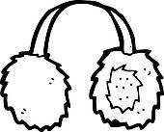

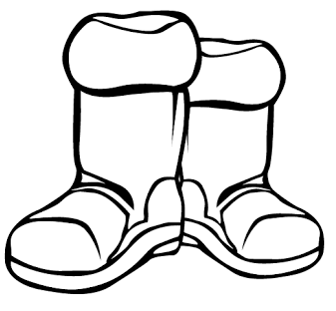
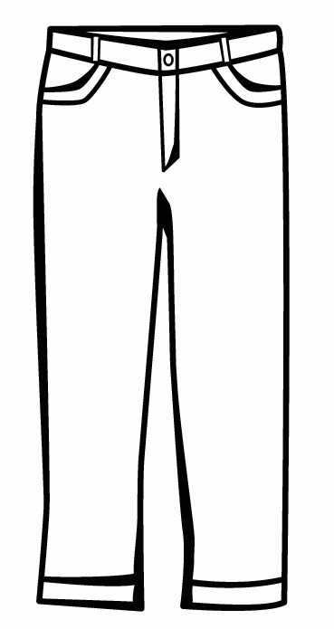
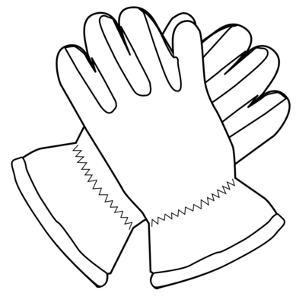
B__ __ck b__ __ t __
B__ __w__ t__ o __ s __ __ s
Y__l__ __w g__ __ v __ s
R__ __ e__ r __ __ f __ s
An o__ a__ ge s__ a __ f
A p__ __k w__ o __ __ y h__ t

ANSWER KEY

A purple jumper
A green coat
Blue jeans

Black boots
Brown trousers
Yellow gloves
Red earmuffs
An orange scarf
A pink woolly hat

