Name: ____________________________ Surname: ____________________________ N^{ber}: ____ Grade/Class: _____
Assessment: _____________________________  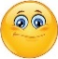  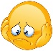 | Date: ___________________________________________________
 | Teacher’s signature:  ___________________________ | Parent’s signature:  ___________________________

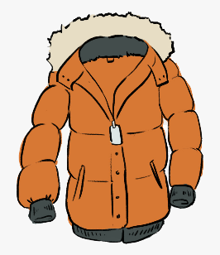
Look at the pictures, unscramble and write.
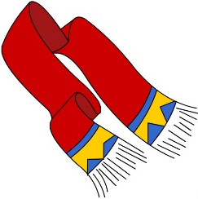
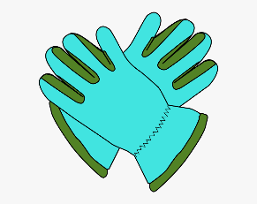

c a t o
c s r a f
__ __ __ __
l g v o s e
__ __ __ __ __
__ __ __ __ __ __

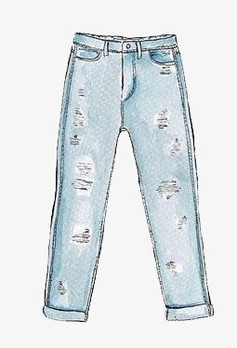
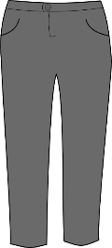
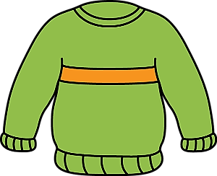

n e a j s
t r e s u s r o
__ __ __ __ __
m p u e j r
__ __ __ __ __ __ __ __
__ __ __ __ __ __

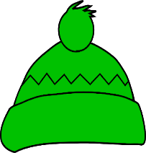
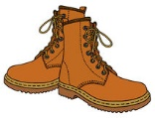
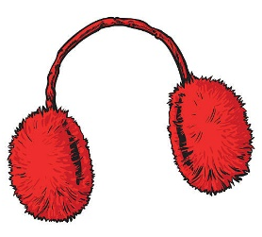

o o y w l l - t a h
s b t o o
r f m u a e f s
__ __ __ __ __ __ __ __
__ __ __ __ __
__ __ __ __ __

ANSWER KEY

Gloves
Scarf
Coat
Jumper
Trousers
Jeans
Earmuffs
Woolly hat
Boots

