TOPIC: Clothes | SUBTOPICS: autumn clothes; seasons; weather; colours | LEVEL: A1
Name: ____________________________ Surname: ____________________________ N^{ber}: ____ Grade/Class: _____

AUTUMN CLOTHES

1) Look at the picture and circle the correct answers.
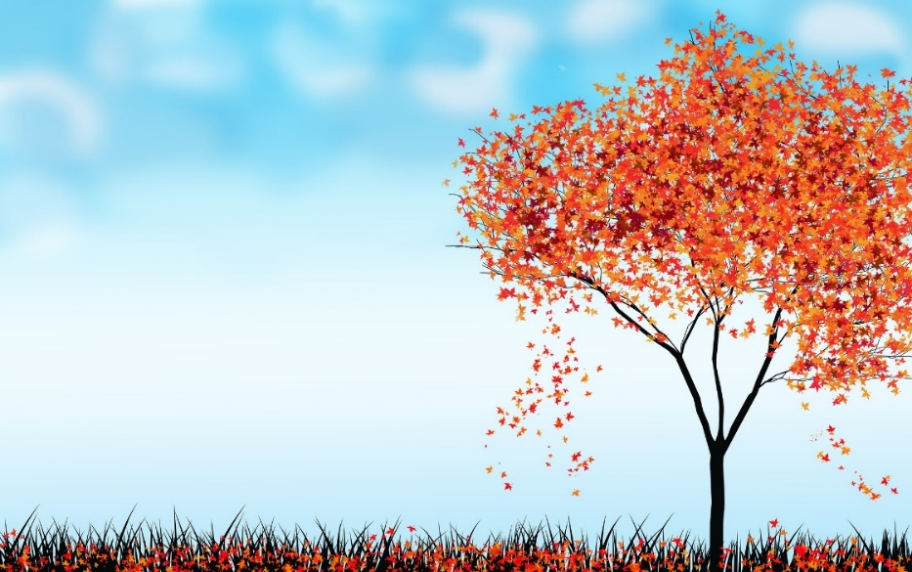

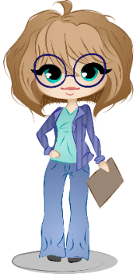

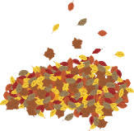
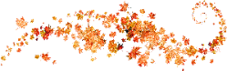

- What’s the season?
It’s autumn It’s winter It’s spring It’s summer

- What’s the weather like?
It’s sunny It’s cloudy It’s rainy It’s chilly It’s hot It’s windy

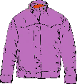
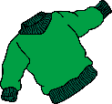
2) What is she wearing? – Read, write and colour.
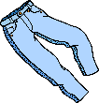
She’s wearing a blue __ a __ k __ t , a green j __ __ p __ __ , blue
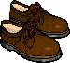
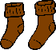
t __ __ __ s __ __ s , grey s __ __ k __ and brown __ h __ __ s .

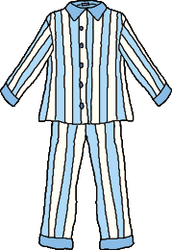
3) Colour the clothes and write.
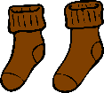
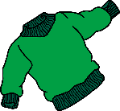
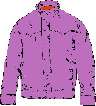
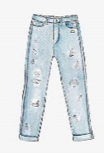
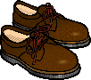

blue jeans | ____________ | ____________ | ____________ | ____________ | ____________

