TOPIC: Clothes | SUBTOPICS: spring clothes; seasons; weather; colours | LEVEL: A1
Name: ____________________________ Surname: ____________________________ N^{ber}: ____ Grade/Class: _____

SPRING CLOTHES

- Listen and number.
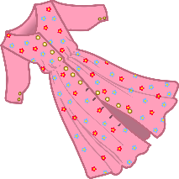
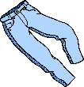
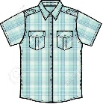

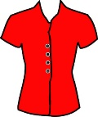
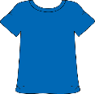
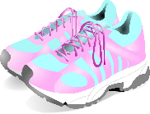

2) Look and write.

S __ __ r __ | D __ e __ __ | T __ o __ s __ r __ | T __ __ c __ s __ t __

T-__ h __ __ t | S __ __ d __ __ s | B __ o __ s __ | T __ a __ n __ r __
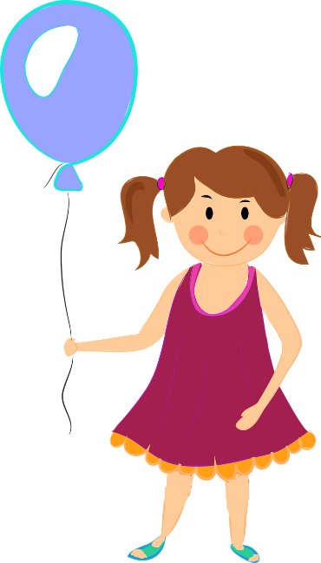
3) Colour and write what they are wearing.
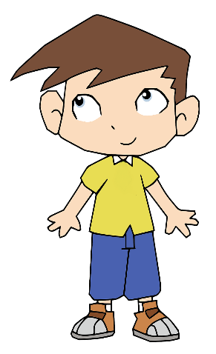
____________________
____________________
____________________
____________________
____________________

He’s wearing _________
____________________
____________________
____________________
____________________

