TOPIC: Clothes | SUBTOPICS: summer clothes; colours | LEVEL: A1
Name: ____________________________ Surname: ____________________________ N^{ber}: ____ Grade/Class: _____
SUMMER CLOTHES

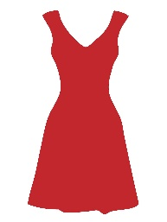
- Match.
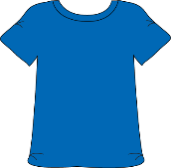
- Dress
- Blouse
- Hat
- Cap
- Skirt
- T-shirt
- Sandals
- Shirt
- Shorts
- Trainers
- Swimsuit
- Flip-flops
- Sunglasses

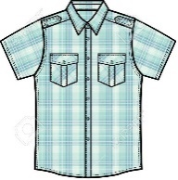
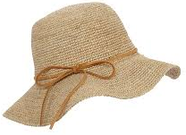

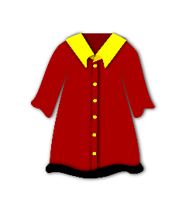
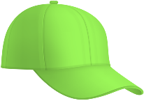

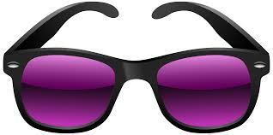
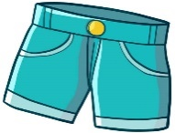

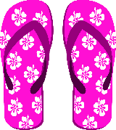
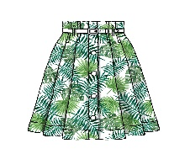

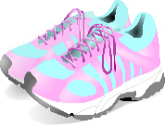
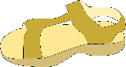

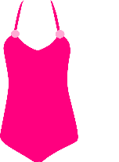

2) Answer.
In summer, what do you like wearing? I like wearing ________________________________________

