TOPIC: Clothes | SUBTOPICS: winter clothes; colours | LEVEL: A1
Name: ____________________________ Surname: ____________________________ N^{ber}: ____ Grade/Class: _____
What is she wearing?
1) Complete the speech bubble.
2) Colour and complete the boxes.
red woolly hat
Hello!
My name´s_______________,
I’m _________ years old.
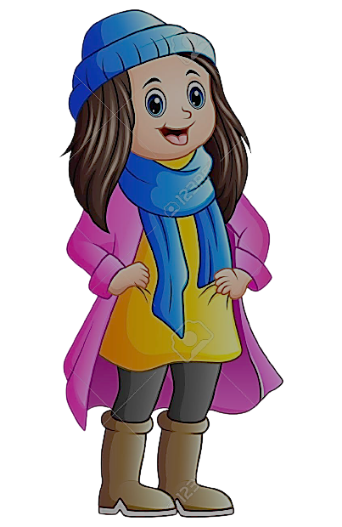

_____________ _____________

_____________ _____________

_____________ _____________

_____________ _____________

_____________ _____________

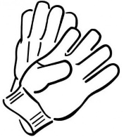
_____________
_____________

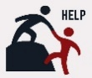

CLOTHES
jumper woolly hat scarf trousers boots coat gloves
COLOURS
red green blue yellow orange black purple white grey pink brown

