TOPIC: Clothes | SUBTOPICS: winter clothes; colours | LEVEL: A1
Name: ____________________________ Surname: ____________________________ N^{ber}: ____ Grade/Class: _____
WINTER CLOTHES/FOOTWEAR
1) Listen and number.

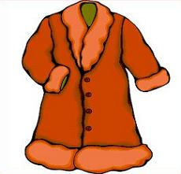
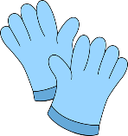
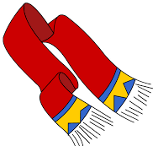
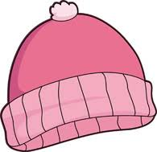
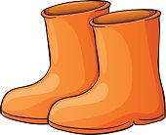
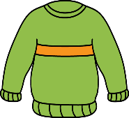

2) Look and write.

C __ __ t
J __ __ p __ __
T __ __ __ s __ __ s

S __ __ __ f
G __ __ v __ s
B __ __ t __
B __ n __ __ t

3) Read, draw and colour.

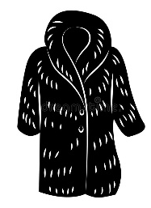

a black coat a green bonnet a blue scarf brown boots pink gloves

