TOPIC: Clothes | SUBTOPICS: spring/summer clothes; colours | LEVEL: A1
Name: ____________________________ Surname: ____________________________ N^{ber}: ____ Grade/Class: _____

Introducing people & describing clothes

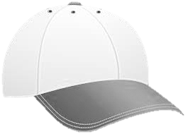
- Colour.
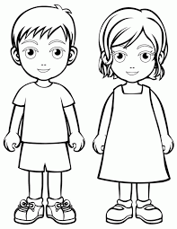

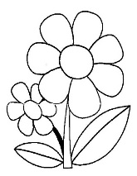

- Write.
This is _________________ (name), ______________________________ (age)
________________________________________________________________________________________________________________________________
________________________________________________________________

What’s his name?
How old is he?

What is he wearing?

- Present your character to the class.

