TOPIC: Clothes | SUBTOPICS: seasons; weather; winter clothes; colours | LEVEL: A1
Name: ____________________________ Surname: ____________________________ N^{ber}: ____ Grade/Class: _____
I – WRITING

1. Label the picture.

2. Colour the boy’s clothes.

S __ __ __ f __ __ k __

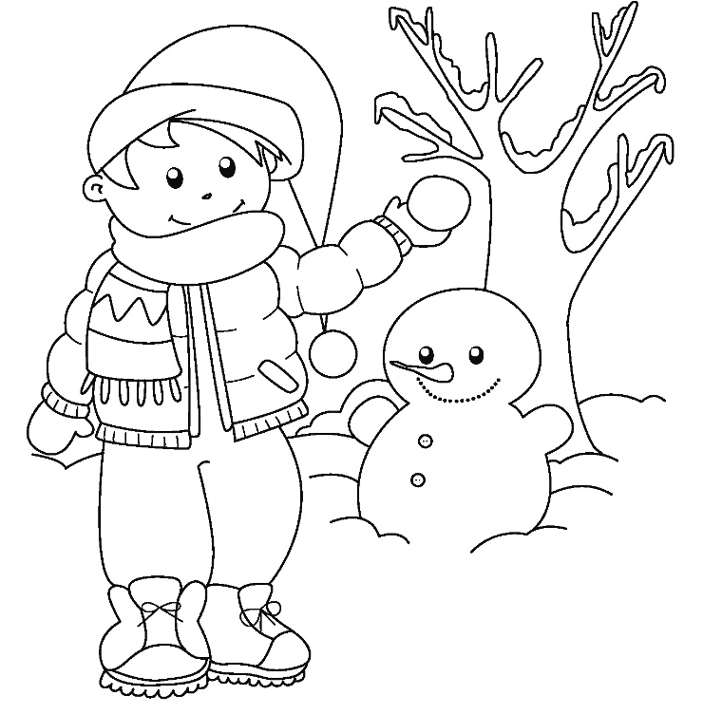

__ n __ __ m __ n

__ n __ w

2. Answer the questions.

____________________________________________________

____________________________________________________

__________ wearing:

_________________________________________

_________________________________________

_________________________________________

_________________________________________

_________________________________________

_________________________________________

What’s the season?

What’s the weather like?

What is the boy wearing?

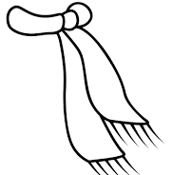

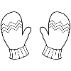

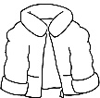

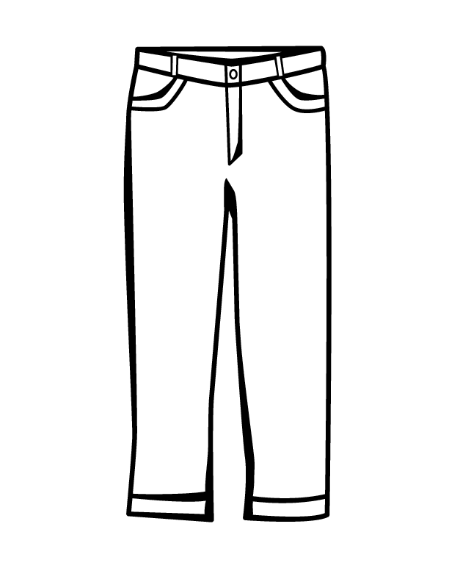

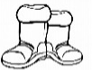

II – SPEAKING

Present your drawing to the class.

