Name: ____________________________ Surname: ____________________________ N^{ber}: ____ Grade/Class: _____
Assessment: _____________________________ | Date: ___________________________________________________
 | Teacher’s signature:  ___________________________ | Parent’s signature:  ___________________________
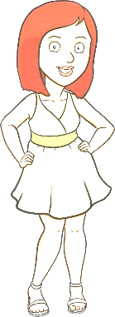
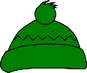
- Colour.

Emma Jenny Alice Peter
- Tick and write.
 | Ema | Jenny | Alice | Peter
coat
t-shirt
dress
trousers
shirt
shorts
hat
scarf
woolly hat
trainers
sandals
boots
- Emma’s wearing a pink dress, _________________________________and ________________________
- Jenny ________________________________________________________________________________
- Alice ________________________________________________________________________________
- Peter ________________________________________________________________________________
ANSWER KEY

 | Ema | Jenny | Alice | Peter
coat |  |  |  | X
t-shirt |  | X | X
dress
trousers |  | X |  | X
shirt |  | X
shorts |  |  | X
hat | X
scarf |  |  |  | X
woolly hat |  |  |  | X
trainers |  | X
sandals | X |  | X
boots |  |  |  | X

- Emma’s wearing a pink dress, a … (colour) hat and … (colour) sandals.
- Jenny’s wearing a … (colour) t-shirt, … (colour) trousers, a … (colour) shirt and … (colour) trainers.
- Alice’s wearing a … (colour) t-shirt, … (colour) shorts and … (colour) sandals.
- Peter’s wearing a … (colour) coat, … (colour) trousers, a … (colour) scarf, a … (colour) woolly hat and … (colour) boots.

