Name: ____________________________ Surname: ____________________________ N^{ber}: ____ Grade/Class: _____
Assessment: _____________________________  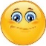 | Date: ___________________________________________________
 | Teacher’s signature:  ___________________________ | Parent’s signature:  ___________________________

Answer the questions.

- What’s your favourite season?

My favourite _______________ __ ____________________.

- In this season, what clothes do you like wearing?

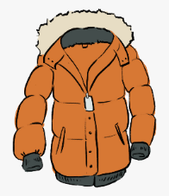
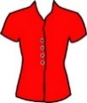
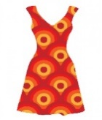
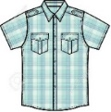
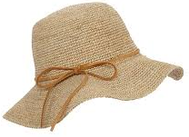
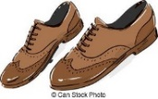
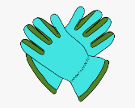

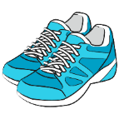
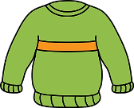
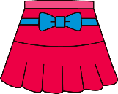
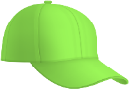
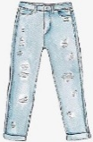
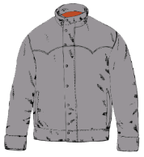
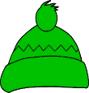
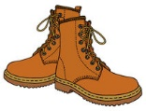
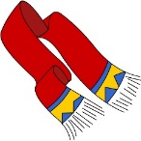
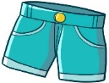
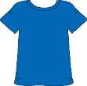

I ______________ wearing __________________ , ________________ , ________________ and _________________ .

- Now, draw.

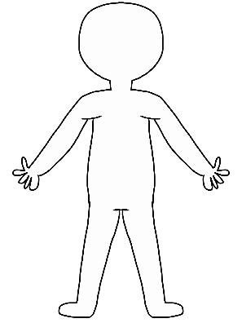

ANSWER KEY
- My favourite season is… (e.g. summer)
- I like wearing… (e.g. t-shirts, shorts, dresses and flip flops)

