Name: ____________________________ Surname: ____________________________ N^{ber}: ____ Grade/Class: _____
Assessment: _____________________________  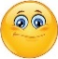 | Date: ___________________________________________________
 | Teacher’s signature:  ___________________________ | Parent’s signature:  ___________________________

Look at the picture. Read the questions and answer.
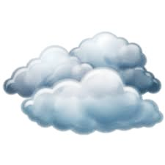
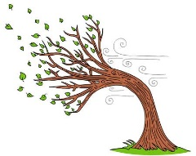

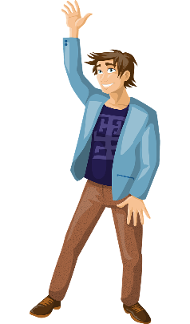

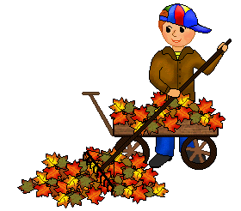

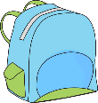

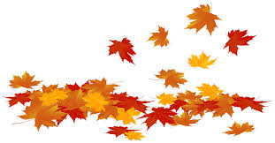
Jack

- It’s __________________.
- It’s ________________ and ______________.
- There are _____________ clouds.
- He’s wearing a _____________, a _____________, ____________
and ______________.
- A blue ________________
a) What season is it?
b) What’s the weather like?
c) How many clouds are there?
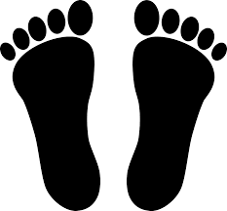
d) What is Jack wearing?

e) What is under the tree?

ANSWER KEY
- autumn
- cloudy / windy
- six
- jacket / jumper / trousers / shoes
- schoolbag

