Name: ____________________________ Surname: ____________________________ N^{ber}: ____ Grade/Class: _____
Assessment: _____________________________ | Date: ___________________________________________________
 | Teacher’s signature:  ___________________________ | Parent’s signature:  ___________________________

- Look, read and complete. Then colour.

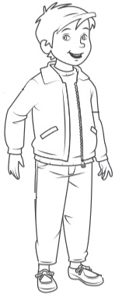

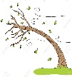
10ºC
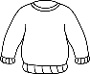
In autumn it’s (1) c__ __ l __ y and (2) w__ __d__ .
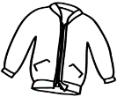
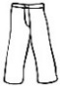
Today, I’m wearing an (3) orange j__ __ p__ __ ,
(4) green t__ __u__e__s , a (5) red j__c__ __t ,
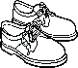
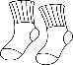
(6) grey s__ ck _ and (7) brown s__ __e__ .

- Put the words in order.
- Put _________________________________.
- What________________________________?
- The _________________________________.
- I’m _________________________________.
a) your / jacket / on / put / .
b) are / what / wearing / you / ?
c) jumper / is / the / yellow / .
d) wearing / jeans / I’m / brown / .

ANSWER KEY
1)
1) cloudy
2) windy
3) jumper
4) trousers
5) jacket
6) socks
7) shoes

2)
a) Put on your jacket.
b) What are you wearing?
c) The jumper is yellow.
d) I’m wearing brown jeans.

