Name: ____________________________ Surname: ____________________________ N^{ber}: ____ Grade/Class: _____
Assessment: _____________________________ | Date: ___________________________________________________
 | Teacher’s signature:  ___________________________ | Parent’s signature:  ___________________________
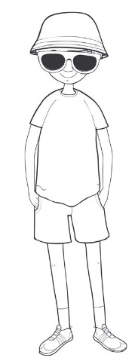
- Colour the boy’s clothes.
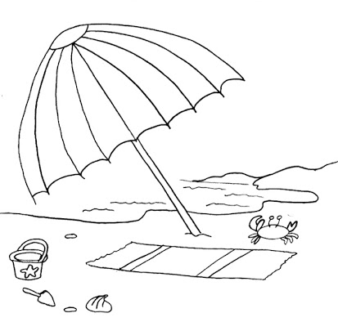

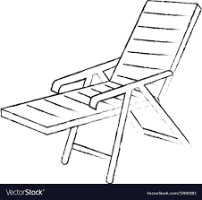

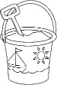

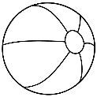

- Write about the picture. Follow the questions.
Today ____________________ and ______________
____________________________________________
Look! This is James.
____________________________________________
____________________________________________
____________________________________________
____________________________________________________________________________________________________________________________________
What’s the weather like?

What’s the season?

Where is James?
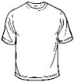
What is he wearing?
(Mention the colours)

