Name: ____________________________ Surname: ____________________________ N^{ber}: ____ Grade/Class: _____
Assessment: _____________________________  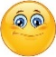 | Date: ___________________________________________________
 | Teacher’s signature:  ___________________________ | Parent’s signature:  ___________________________

- Look at the picture and read the questions. Write one word.

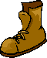
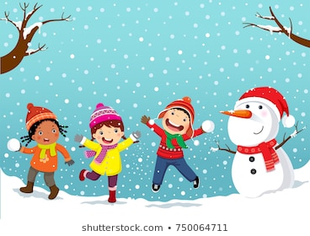

- It’s __________________
- It’s __________________
- A ___________________
- _____________________
a) What season is it?
b) What’s the weather like?
c) What are the three children wearing?
d) What is near the snowman?

- Put the words in order.
- ____________________________________.
- ____________________________________?
- _____________________________________.
- _____________________________________.
a) your / earmfuffs / on / put / .
b) is / what / wearing / he / ?
c) trousers / are / the / blue / .
d) gloves / wearing / she’s / purple / .
ANSWER KEY
1)
a) winter
b) snowy
c) woolly hat / scarf / trousers
d) boots

2)
a) Put on your earmuffs.
b) What is he wearing?
c) The trousers are blue.
d) She’s wearing purple gloves.

