Name: ____________________________ Surname: ____________________________ N^{ber}: ____ Grade/Class: _____
Assessment: _____________________________ | Date: ___________________________________________________
 | Teacher’s signature:  ___________________________ | Parent’s signature:  ___________________________
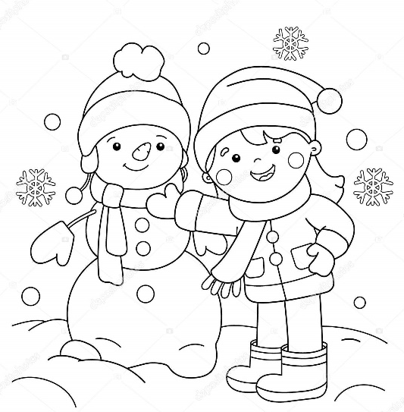
- Colour the girl’s clothes.

- Write about the picture. Follow the questions.
What a fantastic winter day!
____________________________________________
_____________________________________________
____________ wearing:
______________________________________
______________________________________
______________________________________
______________________________________
______________________________________
______________________________________

What’s the weather like?

What is Jane doing?

What is she wearing?
(Mention the colours)

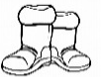
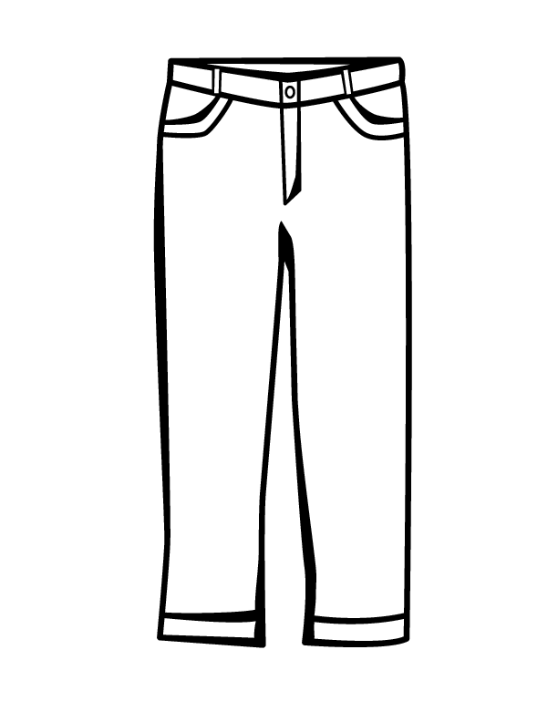
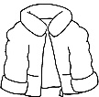
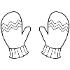
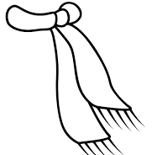
b s o t o

t c a o

l w l o y
t a h
f r a s c

r s e t o u s r

l v s e g o

