|  |  |  |
| --- | --- | --- |
| **TOPIC: Clothes** | **SUBTOPICS: clothes; footwear; accessories** | **LEVEL: A2** |
| **Name:** ____________________________ **Surname:** ____________________________ **Nber: ____ Grade/Class:** _____ | | |

**CLOTHES / FOOTWEAR / ACCESSORIES**

**A - Label the pictures.**

1. ***Clothes***

jeans blazer/jacket skirt trousers suit shorts sweater tracksuit dress shirt leggings sweatshirt raincoat cardigan T-shirt top blouse swimming costume swimming trunks

[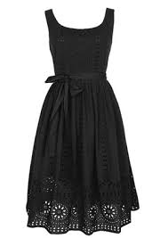](http://images.google.pt/imgres?imgurl=http://www.freewebs.com/bloodredwine/helena-eyelet-dress-in-black-from-delias.jpg&imgrefurl=http://www.freewebs.com/bloodredwine/animalihavebecome.htm&usg=__hvdmx3dgttbj_XoleFkdSzABSiQ=&h=425&w=300&sz=20&hl=pt-PT&start=1&itbs=1&tbnid=op7iKs0ExvlKSM:&tbnh=126&tbnw=89&prev=/images?q%3Ddress%26hl%3Dpt-PT%26sa%3DG%26gbv%3D2%26tbs%3Disch:1)[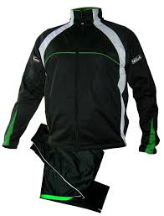](http://images.google.pt/imgres?imgurl=http://www.kokottuk.co.uk/new-training-tracksuit1.jpg&imgrefurl=http://www.kokottuk.co.uk/tracksuits.htm&usg=__NQpIRAYT_1pp4lhiaDA_25bvwAc=&h=1579&w=1208&sz=564&hl=pt-PT&start=3&itbs=1&tbnid=J5CsZNcmMKxtfM:&tbnh=150&tbnw=115&prev=/images?q%3Dtracksuit%26hl%3Dpt-PT%26sa%3DG%26gbv%3D2%26tbs%3Disch:1)[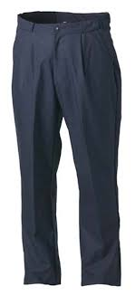](http://images.google.pt/imgres?imgurl=http://www.hilltrek.co.uk/acatalog/Cabrach_trousers_b.jpg&imgrefurl=http://www.hilltrek.co.uk/acatalog/copy_of_Cabrach_Ventile_Trousers.html&usg=__87GM-_rZ32sEFfDlcNAmBHxDoSM=&h=677&w=300&sz=12&hl=pt-PT&start=2&itbs=1&tbnid=cLDR4c2FM5teTM:&tbnh=139&tbnw=62&prev=/images?q%3Dtrousers%26hl%3Dpt-PT%26sa%3DG%26gbv%3D2%26tbs%3Disch:1)[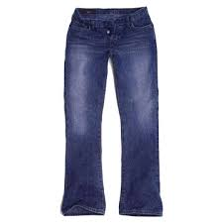](http://images.google.pt/imgres?imgurl=http://rohanmanoharlovetobe.files.wordpress.com/2007/11/jeans.jpg&imgrefurl=http://rohanmanoharlovetobe.wordpress.com/2007/11/01/my-blue-jeans/&usg=__mU-3Sd_pJHRLddsn4jny6W5fYvI=&h=360&w=360&sz=25&hl=pt-PT&start=11&itbs=1&tbnid=XI0AxsBs7JRxsM:&tbnh=121&tbnw=121&prev=/images?q%3Djeans%26hl%3Dpt-PT%26sa%3DG%26gbv%3D2%26tbs%3Disch:1)

[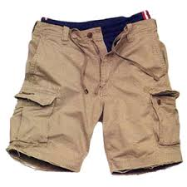](http://images.google.pt/imgres?imgurl=http://www.stpaulrealestateblog.com/st_paul_real_estate/images/2007/08/15/shorts.jpg&imgrefurl=http://www.stpaulrealestateblog.com/st_paul_real_estate/2007/08/short-sales-dem.html&usg=__BS-w5ZUDZiPdoij9bhHQofwZybA=&h=300&w=300&sz=34&hl=pt-PT&start=2&itbs=1&tbnid=b1gSYibmnuPEPM:&tbnh=116&tbnw=116&prev=/images?q%3Dshorts%26hl%3Dpt-PT%26sa%3DG%26gbv%3D2%26tbs%3Disch:1)[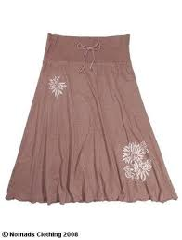](http://images.google.pt/imgres?imgurl=http://www.lovethyspace.co.uk/images/products/1495/large_Skirt%20taupe.jpg&imgrefurl=http://www.lovethyspace.co.uk/product/organic-midi-skirt-taupe/&usg=__P5Yp2FR_ClQ1FjuWuRMKRbAojA4=&h=450&w=342&sz=18&hl=pt-PT&start=15&itbs=1&tbnid=JClvea6VA9PnFM:&tbnh=127&tbnw=97&prev=/images?q%3Dskirt%26hl%3Dpt-PT%26sa%3DG%26gbv%3D2%26tbs%3Disch:1)

|  |  |  |  |  |  |
| --- | --- | --- | --- | --- | --- |
|  |  |  |  |  |  |

**[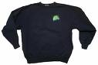](http://images.google.pt/imgres?imgurl=http://www.petersonspointlake.com/images/Sweatshirt-blue.jpg&imgrefurl=http://www.petersonspointlake.com/giftshop.html&usg=__3MsgPe-uHKnN5lQCJuEoudswbf0=&h=299&w=450&sz=38&hl=pt-PT&start=27&itbs=1&tbnid=ihY-1PcSDfBPIM:&tbnh=84&tbnw=127&prev=/images?q%3Dsweat%2Bshirt%26start%3D18%26hl%3Dpt-PT%26sa%3DN%26gbv%3D2%26ndsp%3D18%26tbs%3Disch:1)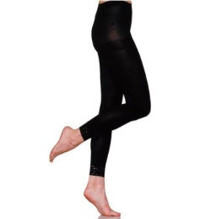[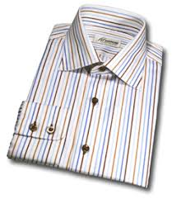](http://images.google.pt/imgres?imgurl=http://www.saintsens.com/chemise-homme-0-339.jpg&imgrefurl=http://www.saintsens.com/chemises-col-italien.htm&usg=__nxl8HYU61lYq8p3-4ehEEVsAbGI=&h=276&w=240&sz=37&hl=pt-PT&start=8&itbs=1&tbnid=Q5enyytnfhKwKM:&tbnh=114&tbnw=99&prev=/images?q%3Dchemise%2Bhomme%26hl%3Dpt-PT%26sa%3DG%26gbv%3D2%26tbs%3Disch:1)[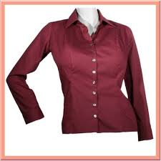](http://images.google.pt/imgres?imgurl=http://www.gwapasila.com/uploaded_images/burgundy_blouse_front-755991.jpg&imgrefurl=http://www.englishforums.com/English/Blouse/ghzpm/post.htm&usg=__njFr-Nv2Xkhip0WdAszt8Izl7q4=&h=400&w=400&sz=23&hl=pt-PT&start=1&itbs=1&tbnid=3ClQH2kxve9Z6M:&tbnh=124&tbnw=124&prev=/images?q%3Dblouse%26hl%3Dpt-PT%26sa%3DG%26gbv%3D2%26tbs%3Disch:1)[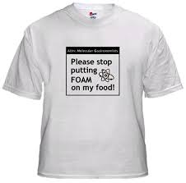](http://images.google.pt/imgres?imgurl=http://softwebcms.com/shoppingcart/images/foam-tshirt.jpg&imgrefurl=http://softwebcms.com/shoppingcart/index.php?main_page%3Dproducts_new&usg=__553li2NFn6UGAagChS5B9Pl2k70=&h=445&w=450&sz=48&hl=pt-PT&start=3&itbs=1&tbnid=AMIOcAdy7rzmfM:&tbnh=126&tbnw=127&prev=/images?q%3Dtshirt%26hl%3Dpt-PT%26sa%3DG%26gbv%3D2%26tbs%3Disch:1)[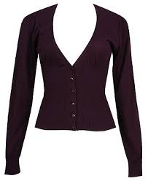](http://images.google.pt/imgres?imgurl=http://www.shinystyle.tv/Forever%2021_cardigan.jpg&imgrefurl=http://www.shinystyle.tv/2007/10/bargain-pick-of-the-week-forev-084940.html&usg=__tSKv_jA5Sdsq3oN6Eg8OquhmoKk=&h=400&w=328&sz=39&hl=pt-PT&start=5&um=1&itbs=1&tbnid=dpQ_wFtzuy6oCM:&tbnh=124&tbnw=102&prev=/images?q%3Dcardigan%26um%3D1%26hl%3Dpt-PT%26sa%3DG%26tbs%3Disch:1)[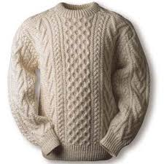](http://images.google.pt/imgres?imgurl=http://www.shirtsnstuff.net/wp-content/uploads/2009/12/sweater.jpg&imgrefurl=http://www.shirtsnstuff.net/&usg=__ejIVpISXg4xUoSbtUAamdJ699Nk=&h=360&w=360&sz=51&hl=pt-PT&start=1&itbs=1&tbnid=yG826xZheW-QiM:&tbnh=121&tbnw=121&prev=/images?q%3Dsweater%26hl%3Dpt-PT%26sa%3DG%26gbv%3D2%26tbs%3Disch:1)**

|  |  |  |  |  |  |  |
| --- | --- | --- | --- | --- | --- | --- |
|  |  |  |  |  |  |  |

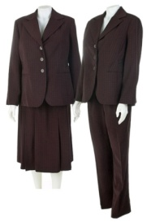

**[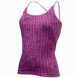](http://www.decathlon.pt/products-pictures/gd-asset_15518907.jpg)[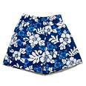](http://images.google.pt/imgres?imgurl=http://www.babysorganicnursery.com/shop/images/boys_swimming_trunks.jpg&imgrefurl=http://www.babysorganicnursery.com/home/dp1/page_16_4/Boys&usg=__oe07RhYlAMLL0lD8BtDhJ-MAULU=&h=300&w=300&sz=101&hl=pt-PT&start=7&itbs=1&tbnid=wME_FSU_7Bg38M:&tbnh=116&tbnw=116&prev=/images?q%3Dswimming%2Btrunks%26hl%3Dpt-PT%26sa%3DG%26gbv%3D2%26tbs%3Disch:1)[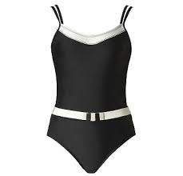](http://images.google.pt/imgres?imgurl=http://z.about.com/d/accessories/1/0/T/B/-/-/maillot.jpg&imgrefurl=http://accessories.about.com/od/latesttrends/tp/swimsuit-styles.htm&usg=__vSfFqFjJ-HKxvjq3eEFCMaXGe6E=&h=355&w=368&sz=30&hl=pt-PT&start=21&itbs=1&tbnid=nQ7XdX47WNZtlM:&tbnh=118&tbnw=122&prev=/images?q%3Dswimming%2Bsuit%26start%3D18%26hl%3Dpt-PT%26sa%3DN%26gbv%3D2%26ndsp%3D18%26tbs%3Disch:1)[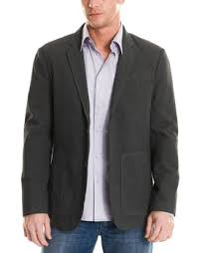](http://images.google.pt/imgres?imgurl=http://homensmodernos.files.wordpress.com/2007/07/another-blazer.jpg&imgrefurl=http://homensmodernos.wordpress.com/2007/07/28/camisassetas-uso-pra-fora-ou-pra-dentro-das-calcas/respeitando-o-limite-do-blazer/&usg=__vtn6tE1WoNAMJe_KBTzDBIaNWPM=&h=348&w=271&sz=29&hl=pt-PT&start=2&itbs=1&tbnid=o4GP-ltHaYcfuM:&tbnh=120&tbnw=93&prev=/images?q%3Dblazer%26hl%3Dpt-PT%26sa%3DG%26gbv%3D2%26tbs%3Disch:1)[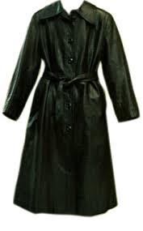](http://images.google.pt/imgres?imgurl=http://www.bilbaoweb.com/vizcaya/bilbao/cascovi/somera/union/graficos/gabardina.gif&imgrefurl=http://www.bilbaoweb.com/vizcaya/bilbao/cascovi/somera/union/2mano.html&usg=__Ad4nOzr-y9WlKlvMPuYygiufFpg=&h=378&w=234&sz=40&hl=pt-PT&start=8&itbs=1&tbnid=5WNkomdxxFEj4M:&tbnh=122&tbnw=76&prev=/images?q%3Dgabardina%26hl%3Dpt-PT%26sa%3DG%26gbv%3D2%26tbs%3Disch:1)**

|  |  |  |  |  |  |
| --- | --- | --- | --- | --- | --- |
|  |  |  |  |  |  |

1. ***Underwear***

Vest tights socks knickers bra boxers

[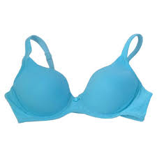](http://images.google.pt/imgres?imgurl=http://www.goerieblogs.com/lifestyle/hertimes/wp-content/uploads/2010/01/bra.jpg&imgrefurl=http://www.goerieblogs.com/lifestyle/hertimes/?cat%3D10&usg=__E3SG1n9JHoPNrhy1Sr19vDaz1_4=&h=360&w=360&sz=15&hl=pt-PT&start=6&itbs=1&tbnid=EpJOB1rUkBeXVM:&tbnh=121&tbnw=121&prev=/images?q%3Dbra%26hl%3Dpt-PT%26sa%3DG%26gbv%3D2%26tbs%3Disch:1)[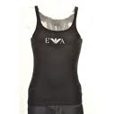](http://images.google.pt/imgres?imgurl=http://www.mainlinemenswear.co.uk/shopimages/products/normal/0000%20ss%20pics%20976%20075_thumb.jpg&imgrefurl=http://menswear.mainlinemenswear.co.uk/menswear/Armani%20T%20Shirt&usg=__3sgs615KmjzBV2go3d_3iSXmHlY=&h=450&w=450&sz=12&hl=pt-PT&start=43&um=1&itbs=1&tbnid=UAd6_X9OydOdZM:&tbnh=127&tbnw=127&prev=/images?q%3Dvest%2Bunderwear%26start%3D36%26um%3D1%26hl%3Dpt-PT%26sa%3DN%26ndsp%3D18%26tbs%3Disch:1)**[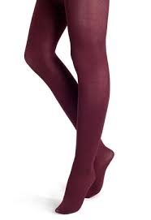](http://images.google.pt/imgres?imgurl=http://www.coutureinthecity.com/wp-content/uploads/2008/11/huetights.jpg&imgrefurl=http://www.coutureinthecity.com/2008/11/26/haute-winter-trend-colored-tights/&usg=__eCUcDkCIFgIM5aMWkRxLdeWNIUo=&h=452&w=310&sz=15&hl=pt-PT&start=3&itbs=1&tbnid=RtjKhDvp8iJElM:&tbnh=127&tbnw=87&prev=/images?q%3Dtights%26hl%3Dpt-PT%26sa%3DN%26gbv%3D2%26ndsp%3D18%26tbs%3Disch:1)**

[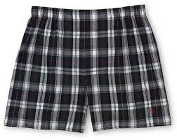](http://images.google.pt/imgres?imgurl=http://z.about.com/d/couponing/1/0/6/s/ns_boxers52.jpg&imgrefurl=http://couponing.about.com/od/appareldealscoupons/ig/Great-Guy-Gifts/ns_boxers52.htm&usg=__KU2uGMyN5ECnx-asvd5Qbk_izCs=&h=378&w=475&sz=28&hl=pt-PT&start=3&itbs=1&tbnid=qo5hpEqNnfcdUM:&tbnh=103&tbnw=129&prev=/images?q%3Dboxers%26hl%3Dpt-PT%26sa%3DG%26gbv%3D2%26tbs%3Disch:1)[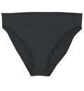](http://images.google.pt/imgres?imgurl=http://oxleylearning.org/germandictionary/wp-content/uploads/2008/12/knickers.jpg&imgrefurl=http://oxleylearning.org/germandictionary/2008/12/knickers/&usg=__bdPzG2OSnPvbH4nHqhnsu0STaDc=&h=500&w=460&sz=12&hl=pt-PT&start=12&um=1&itbs=1&tbnid=yjgVGRbWc0a7sM:&tbnh=130&tbnw=120&prev=/images?q%3Dknickers%26um%3D1%26hl%3Dpt-PT%26sa%3DN%26ndsp%3D18%26tbs%3Disch:1)[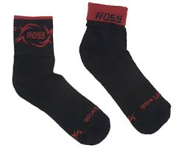](http://images.google.pt/imgres?imgurl=http://www.hossmtb.com/shop/images/socks-red.jpg&imgrefurl=http://www.hossmtb.com/shop/index.php?main_page%3Dproduct_info%26products_id%3D9&usg=__hUDV2Qx1JehOgeWTm9m8MMMrgOc=&h=333&w=400&sz=23&hl=pt-PT&start=17&itbs=1&tbnid=rBtQDV80b4DNoM:&tbnh=103&tbnw=124&prev=/images?q%3Dsocks%26hl%3Dpt-PT%26sa%3DG%26gbv%3D2%26tbs%3Disch:1)

|  |  |  |  |  |  |
| --- | --- | --- | --- | --- | --- |
|  |  |  |  |  |  |

***3)******Footwear***

shoes boots high heels sandals sneakers/trainers flip-flops

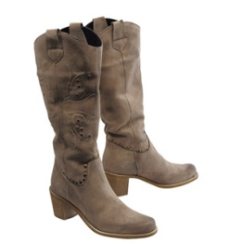

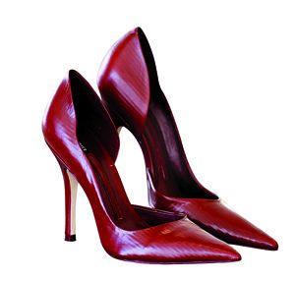**[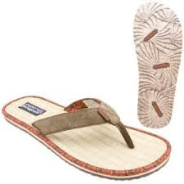](http://images.google.pt/imgres?imgurl=http://keetsa.com/blog/wp-content/uploads/2007/06/hemp-sandals-by-patagonia.jpg&imgrefurl=http://keetsa.com/blog/eco-friendly/hot-recycled-rubber-sandals-by-patagonia/&usg=__4HzvaKyEZUXHf-LsALH2WzOKfj8=&h=300&w=300&sz=12&hl=pt-PT&start=26&um=1&itbs=1&tbnid=yl34SxxxjzigXM:&tbnh=116&tbnw=116&prev=/images?q%3Dsandals%26start%3D18%26um%3D1%26hl%3Dpt-PT%26sa%3DN%26ndsp%3D18%26tbs%3Disch:1)**

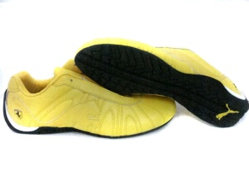[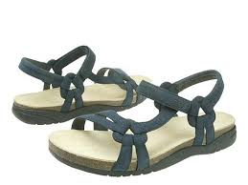](http://images.google.pt/imgres?imgurl=http://z.about.com/d/shoes/1/0/M/L/teva_sandals.jpg&imgrefurl=http://shoes.about.com/od/sandals/ig/sandals/Teva-Sandals.htm&usg=__2hHzE2auoaAgsWNUeqsGTooME_o=&h=360&w=480&sz=19&hl=pt-PT&start=22&um=1&itbs=1&tbnid=jnZi7gtOLSPL9M:&tbnh=97&tbnw=129&prev=/images?q%3Dsandals%26start%3D18%26um%3D1%26hl%3Dpt-PT%26sa%3DN%26ndsp%3D18%26tbs%3Disch:1)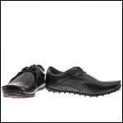

|  |  |  |  |  |  |
| --- | --- | --- | --- | --- | --- |
|  |  |  |  |  |  |

***4) Accessories***

belt sunglasses tie cap hat handbag scarf gloves

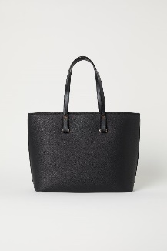

http://www.pursepage.com/wp-content/uploads/2008/04/coach-ergo-patent-handbag-pink.jpg**[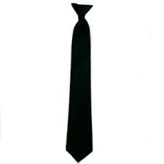](http://images.google.pt/imgres?imgurl=http://livorno.theoffside.com/files/2008/12/sp_tie.jpg&imgrefurl=http://livorno.theoffside.com/livorno/team-news/livorno-tie-diamanti-scores-a-beauty-or-its-deja-vue-again.html&usg=__yUXO_tvaYf2a7RiAkLoR0Y3R-Dg=&h=300&w=300&sz=5&hl=pt-PT&start=2&um=1&itbs=1&tbnid=nb3MG-Dm6gtaSM:&tbnh=116&tbnw=116&prev=/images?q%3Dtie%26um%3D1%26hl%3Dpt-PT%26sa%3DG%26tbs%3Disch:1)**[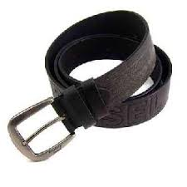](http://images.google.pt/imgres?imgurl=http://www.traderscity.com/board/userpix9/7142-leather-brown-belt-men-1.jpg&imgrefurl=http://www.traderscity.com/board/products-1/offers-to-sell-and-export-1/sell-top-leather-brown-belt-from-men-18436/&usg=__mxcumVVCL7oCAFWIGnxSCRzBQSI=&h=300&w=300&sz=11&hl=pt-PT&start=6&um=1&itbs=1&tbnid=jXQjj1JMOE_F-M:&tbnh=116&tbnw=116&prev=/images?q%3Dbelt%26um%3D1%26hl%3Dpt-PT%26sa%3DG%26tbs%3Disch:1)[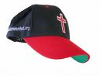](http://images.google.pt/imgres?imgurl=http://www.ptsalt.com/files/images/products/cross_cap.jpg&imgrefurl=http://www.ptsalt.com/products/cross_cap&usg=__EbXsSdN8zTablGMhoVRndHt0_ho=&h=375&w=500&sz=14&hl=pt-PT&start=16&um=1&itbs=1&tbnid=zCjDM32O8i2BuM:&tbnh=98&tbnw=130&prev=/images?q%3Dcap%26um%3D1%26hl%3Dpt-PT%26sa%3DG%26tbs%3Disch:1)[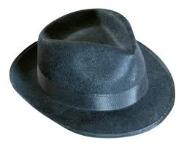](http://images.google.pt/imgres?imgurl=http://seodebrigadeiro.files.wordpress.com/2009/01/black-hat.jpg&imgrefurl=http://seodebrigadeiro.wordpress.com/2009/01/31/black-hat-seo/&usg=__a2Nx621H-ajHXC4xMg3X9Ru4PPA=&h=1217&w=1527&sz=956&hl=pt-PT&start=1&um=1&itbs=1&tbnid=yTfLw3IiLvxfKM:&tbnh=120&tbnw=150&prev=/images?q%3Dhat%26um%3D1%26hl%3Dpt-PT%26sa%3DG%26tbs%3Disch:1)[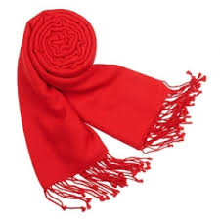](http://images.google.pt/imgres?imgurl=http://bluebirdsaresonatural.files.wordpress.com/2008/03/pashmina-scarf.jpg&imgrefurl=http://bluebirdsaresonatural.wordpress.com/2008/03/10/making-your-mind-up/&usg=__xNf-AJp0Bc9rzK78Tp7J2X6o180=&h=300&w=300&sz=56&hl=pt-PT&start=2&um=1&itbs=1&tbnid=0IH4XDxjeI9tMM:&tbnh=116&tbnw=116&prev=/images?q%3Dscarf%26um%3D1%26hl%3Dpt-PT%26sa%3DG%26tbs%3Disch:1)[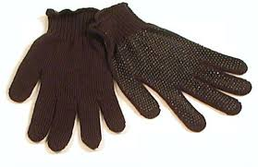](http://images.google.pt/imgres?imgurl=http://postaluniformsdirect.com/images/gloves/GripDotGloves.jpg&imgrefurl=http://postaluniformsdirect.com/gloves.htm&usg=__6uakqf68YB6ifp9-GVlDbIwQm8c=&h=365&w=563&sz=51&hl=pt-PT&start=1&um=1&itbs=1&tbnid=P88pkZkhsj88QM:&tbnh=86&tbnw=133&prev=/images?q%3Dgloves%26um%3D1%26hl%3Dpt-PT%26sa%3DG%26tbs%3Disch:1)

[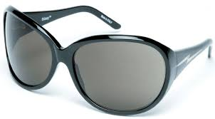](http://images.google.pt/imgres?imgurl=http://www.highsnobiety.com/uploads/pics/stussy_ss08_sunglasses_10.jpg&imgrefurl=http://www.highsnobiety.com/news/2008/04/23/stussy-2008-sunglass-collection/&usg=__p_TSNK265FRqUd-1XLqmKHzD8A0=&h=295&w=533&sz=19&hl=pt-PT&start=16&um=1&itbs=1&tbnid=9r4oPjHSUG6-PM:&tbnh=73&tbnw=132&prev=/images?q%3Dsunglass%26um%3D1%26hl%3Dpt-PT%26sa%3DN%26tbs%3Disch:1)

|  |  |  |  |  |  |  |  |
| --- | --- | --- | --- | --- | --- | --- | --- |
|  |  |  |  |  |  |  |  |

**B. Describe what you are wearing.**

____________________________________________________________________________________________________________________________________________________________________________________________