TOPIC: COUNTRIES | SUBTOPICS: ADJECTIVES – COLOURS | LEVEL: A1
Name: Surname: N^{ber}: Grade/Class:

European Countries

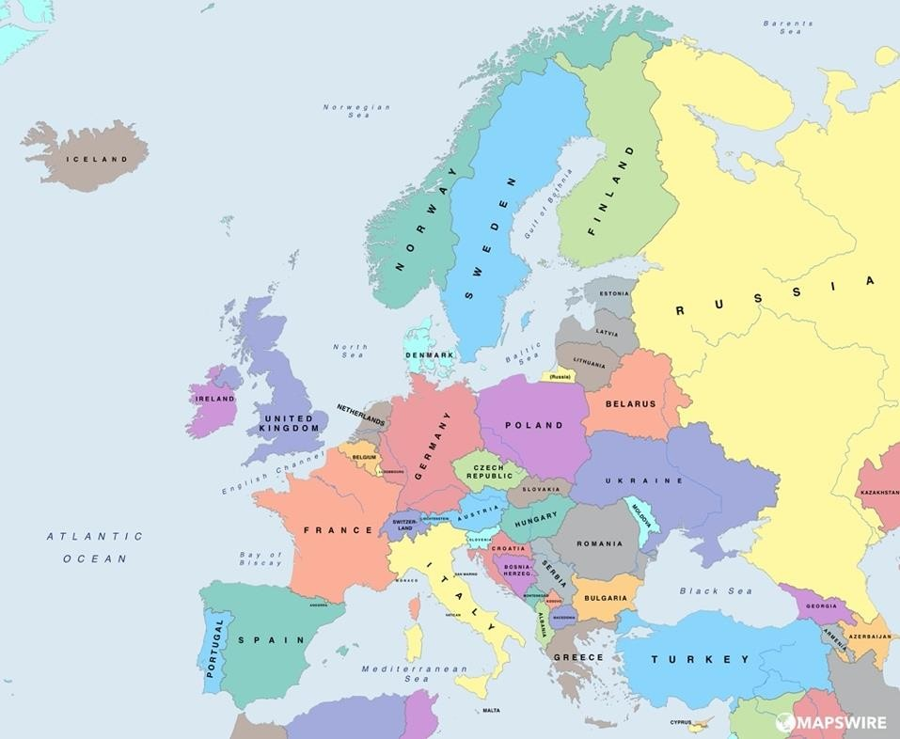
Draw a line to the country on the map
Portugal
France
Austria
The United Kingdom
Romania
Germany
Czech Republic
Switzerland
Bulgaria
Belgium
Hungary

Norway | Sweden | Finland

Spain
Italy
Greece
Turkey

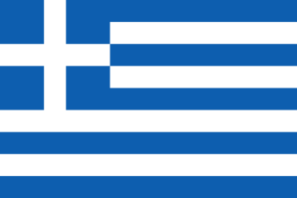
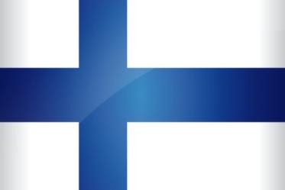
Greece
The Greek flag is blue and white.
Finland
The Finnish flag is blue and white.
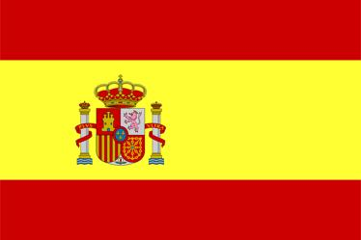
SPAIN
The Spanish flag is yellow and red.
The United Kingdom
The British flag is blue, white and red.
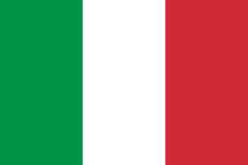
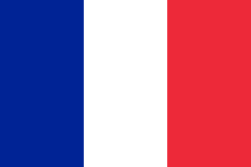
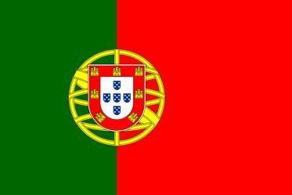
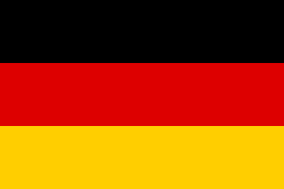
Italy
The Italian flag is green white and red.
France
The French flag is blue, white and red.
Portugal
The Portugese flag is green and red.
Germany
The German flag is black, yellow and red.

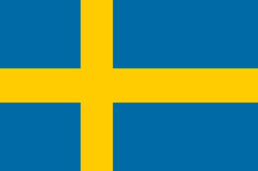
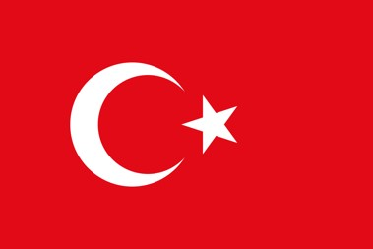
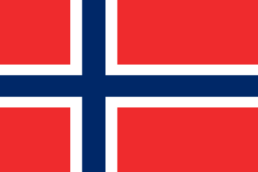
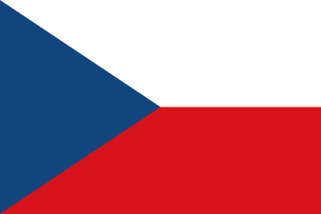
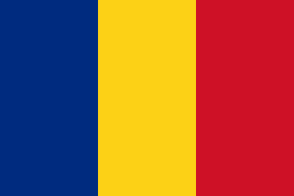
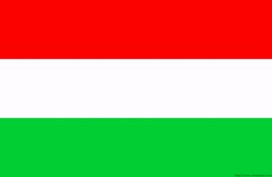
Sweden
The Swedish flag is blue and.
Turkey
The Turkish flag is red and white.
Norway
The Norwegian flag is blue, red and white.
Czeck republic
The Czech flag is red, blue and white.
Bulgaria
The Bulgarian flag is red, blue and white.
Hungary
The Hungarian flag is red, green and white.

Fill in the blanks
The flag is red, blue and . The country of this flag is Bulgaria.

The Spanish flag is and red.
The country of this flag is .

The flag is , white and . The country of this flag is France.

The Greek flag is and . The country of this flag is .

The flag is , white and red. The country of this flag is Italy.

The British flag is , white and . The country of this flag is The United Kingdom.

The flag is , and red. The country of this flag is Germany.

The flag is and . The country of this flag is Finland.

