Name: ____________________________ Surname: ____________________________ N^{ber}: ____ Grade/Class: _____
Assessment: _____________________________ | Date: ___________________________________________________
 | Teacher’s signature:  ___________________________ | Parent’s signature:  ___________________________

- Listen and fill in the name of the nationalities.
Example: Spain - Spanish
Finland - ___________________________
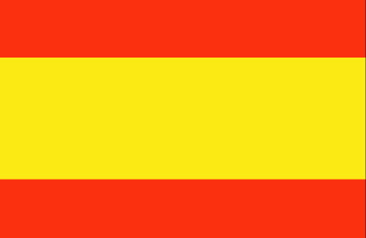
Greece - ___________________________
Germany - ___________________________
Italy - ___________________________
Portugal - ___________________________
Spain - ___________________________
Ireland - ___________________________
Turkey - ___________________________
- Listen and add the correct number under the flags.
Example: Number 1. The Spanish flag is yellow and red.
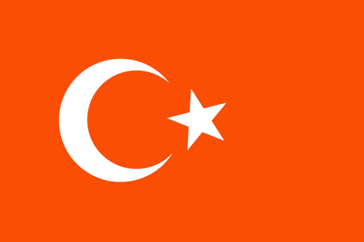
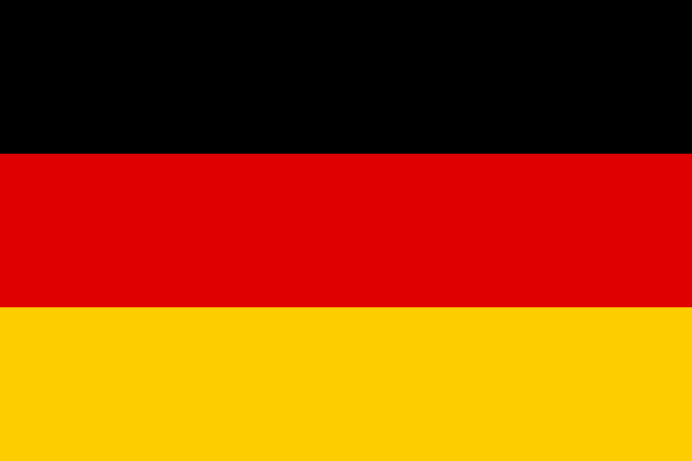
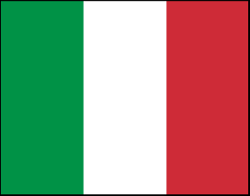
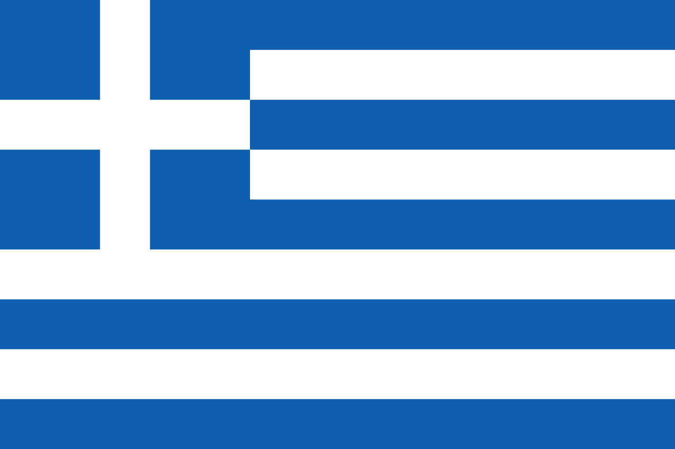

__________________ __________________ __________________ _________________

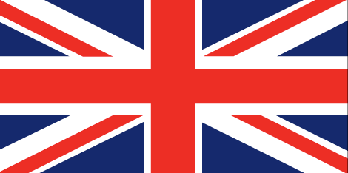
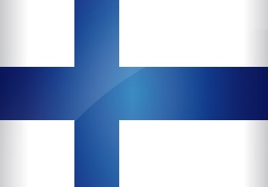
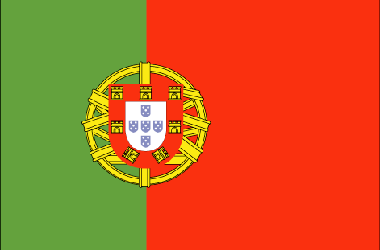
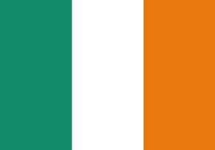

__________________ __________________ __________________ _________________
Transcript 1:
Finland - Finnish
Greece - Greek
Germany - German
Italy - Italian
Portugal - Portuguese
Spain – Spanish
Ireland – Irish
Turkey – Turkish

Transcript 2:
- The Spanish flag is yellow and red.
- The Finnish flag has a blue cross on a white background.
- The German flag is black, red and yellow.
- The Greek flag is white and blue and has a small cross.
- The UK flag is red, blue and white.
- The Italian flag is green, white and red.
- The Turkish flag is red with a white star and a crescent.
- The Portuguese flag is green and red with the national coat of arms.
- The Irish flag is green, white and orange.

