Name: ____________________________ Surname: ____________________________ N^{ber}: ____ Grade/Class: _____
Assessment: _____________________________ | Date: ___________________________________________________
 | Teacher’s signature:  ___________________________ | Parent’s signature:  ___________________________

Listen and write where they come from and then answer the questions.
Example: Tom is from Scotland

Juan is from ______________________. Marja is from ______________________.

Zohra is from ______________________. Colin is from ______________________.

Antonio is from ______________________. Cathryn is from ______________________.

Tim is from ______________________. Isabella is from ______________________.

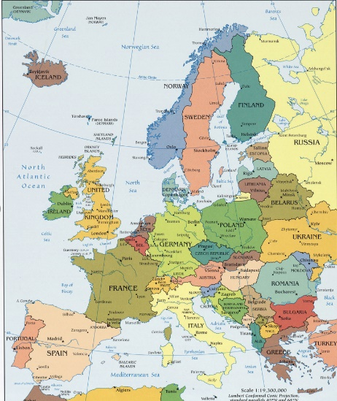

Key:

Tom is from Scotland.
Juan is from Portugal.
Marja is from Finland.
Zohra is from Turkey.
Colin is from Ireland.
Antonio is from Spain.
Cathryn is from Wales.
Tim is from England.
Isabella is from Italy.

