Name: ____________________________ Surname: ____________________________ N^{ber}: ____ Grade/Class: _____
Assessment: _____________________________ | Date: ___________________________________________________
 | Teacher’s signature:  ___________________________ | Parent’s signature:  ___________________________

Read the words and talk about what they are doing.
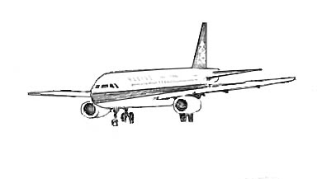

Brittany > airplane > holiday > Ireland = Brittany is on an airplane and she is going on holiday to Ireland.
Sam > school > learn > geography > Spain
Mervi > Finnish > lives > Finland
Ayse > Turkey > loves > beach
Trevor > visiting > capital > Portugal
Maria > working > restaurant > Wales
Paddy > wants > visit > Dublin > Ireland
Maya > playing > friends > Athens >Greece

Talk about yourself now.
What are you doing just now?
Where are you?
What country do you come from?

