Name: ____________________________ Surname: ____________________________ N^{ber}: ____ Grade/Class: _____
Assessment: _____________________________ | Date: ___________________________________________________
 | Teacher’s signature:  ___________________________ | Parent’s signature:  ___________________________

Pair work: Ask questions and give answers.
Example: Student A: Where are you from? - Student B: I am from Finland. I am Finnish.

Student A
Turkey, Greece, Portugal, England, Scotland.

2. Explain how the flags look like to your partner.
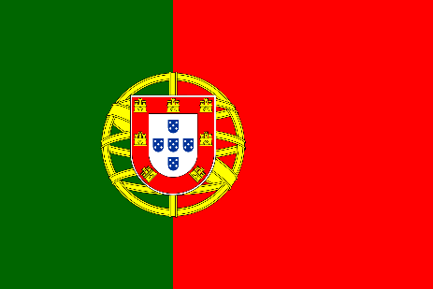
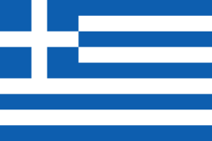
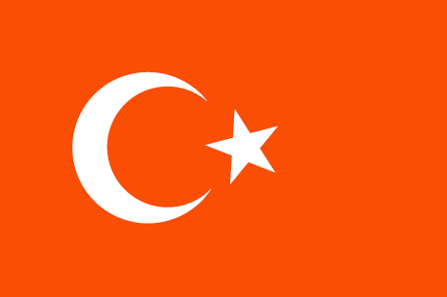

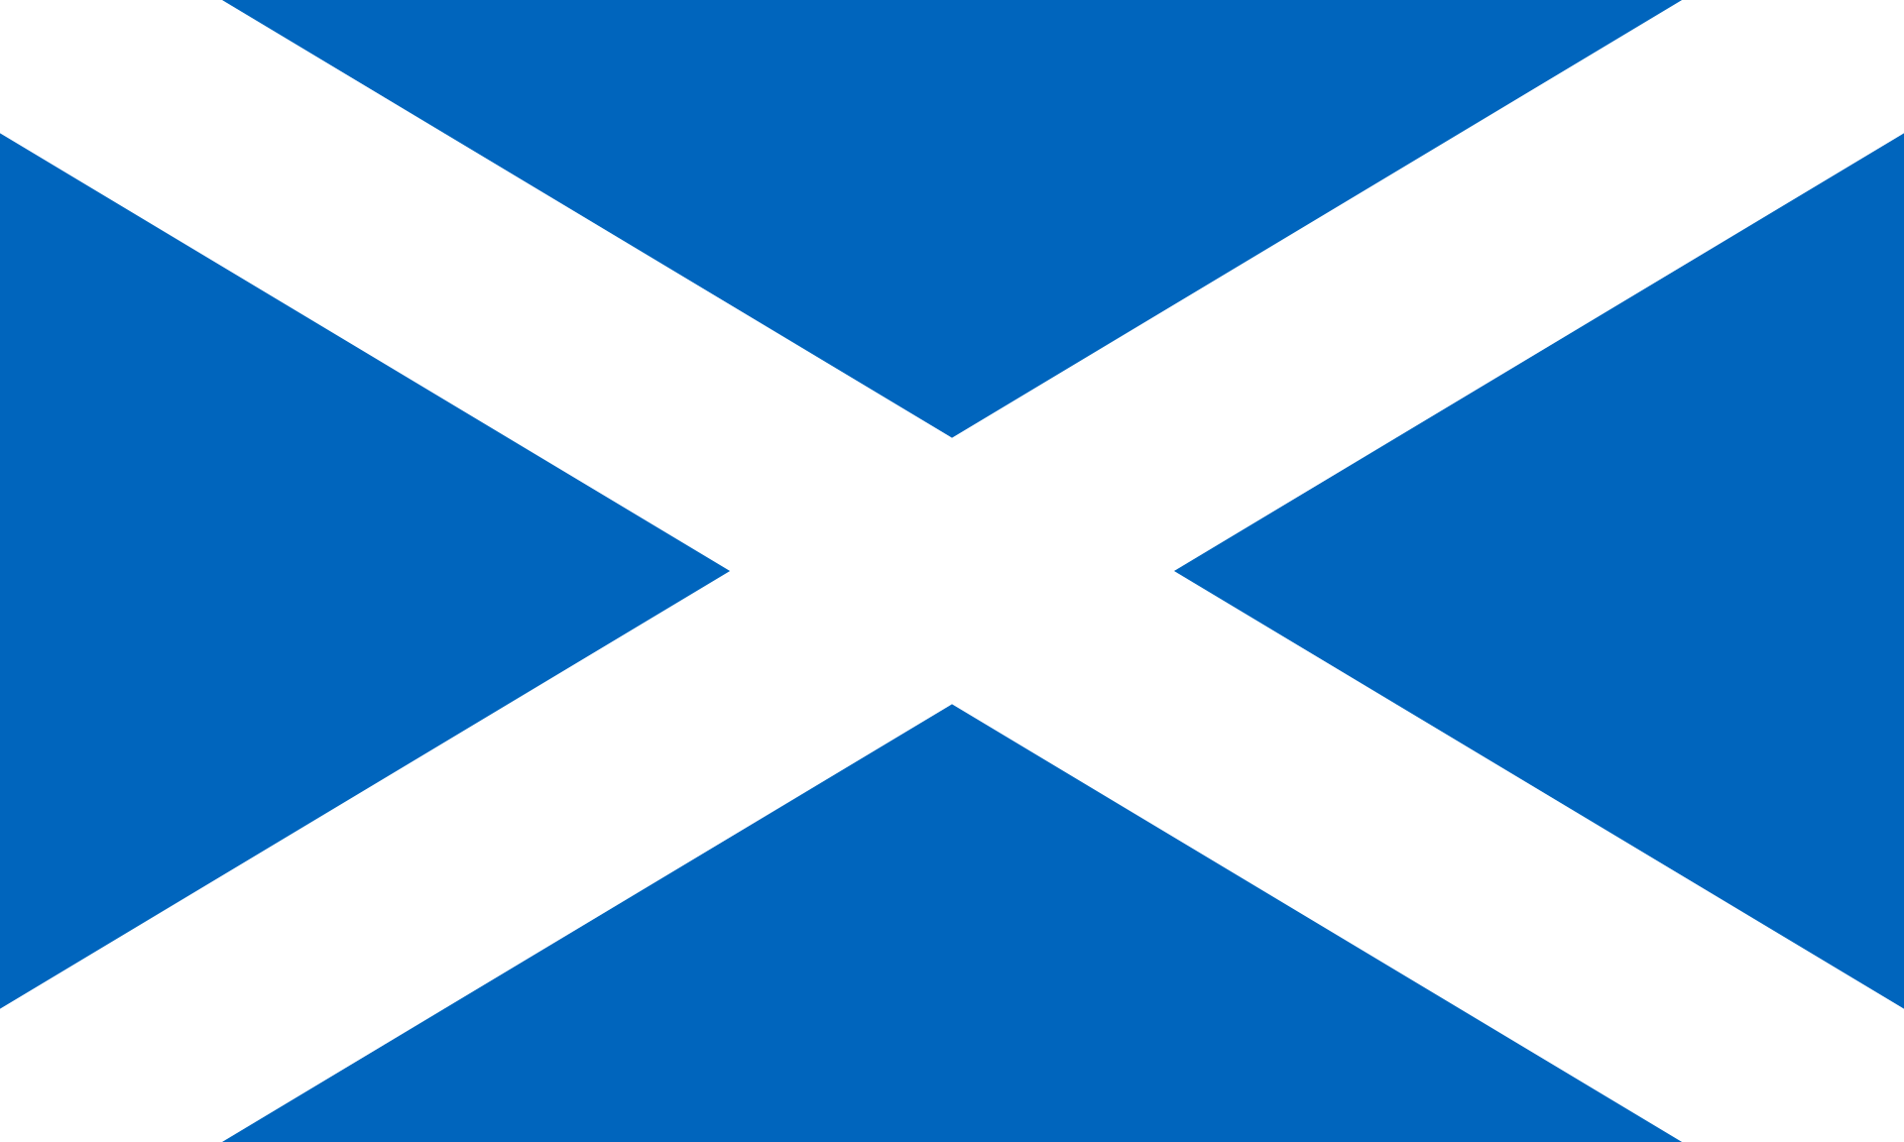
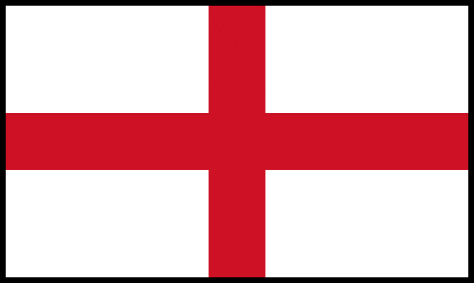
This Photo by Unknown Author is licensed under CC BY-SA
This Photo by Unknown Author is licensed under CC BY-SA

Pair work: Ask questions and give answers.
Example: Student B: Where are you from? - Student A: I am from Finland. I am Finnish.

Student B
Wales, Spain, Germany, Northern Ireland, Italy.

2. Explain how the flags look like to your partner.

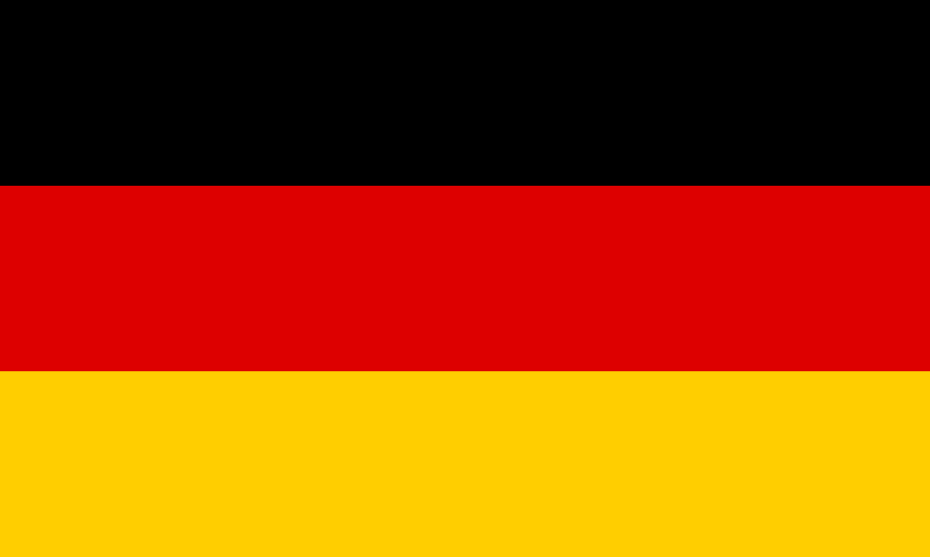
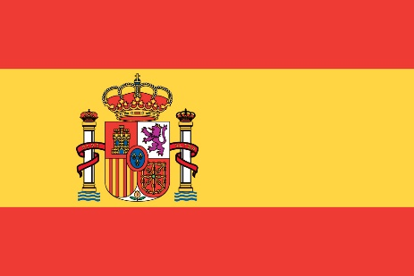
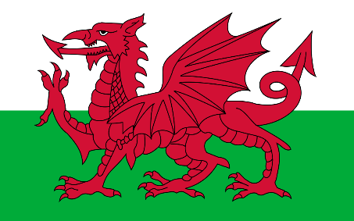
This Photo by Unknown Author is licensed under CC BY-SA

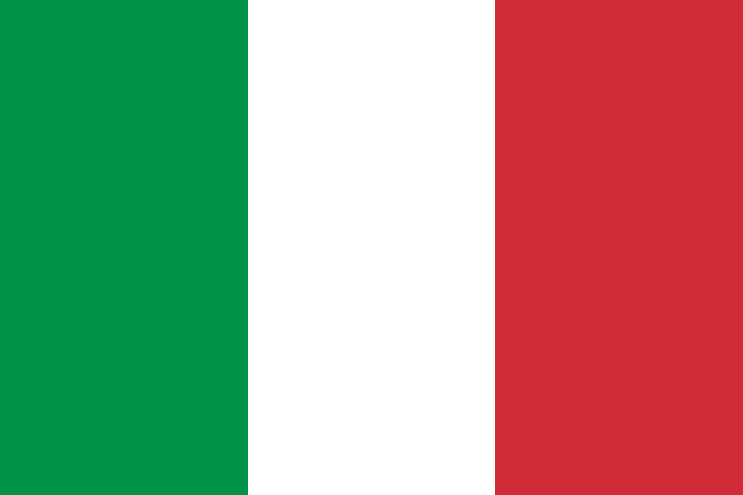
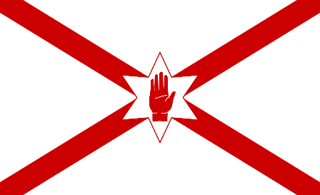
This Photo by Unknown Author is licensed under CC BY-SA

