Name: ____________________________ Surname: ____________________________ N^{ber}: ____ Grade/Class: _____
Assessment: _____________________________ | Date: ___________________________________________________
 | Teacher’s signature:  ___________________________ | Parent’s signature:  ___________________________

Circle the correct country.
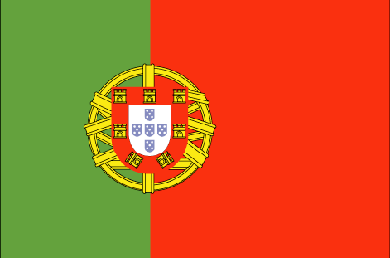
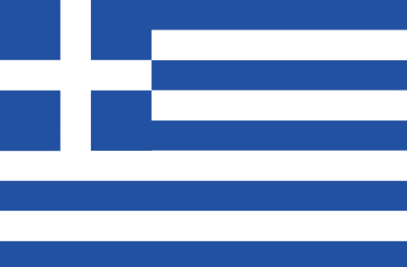
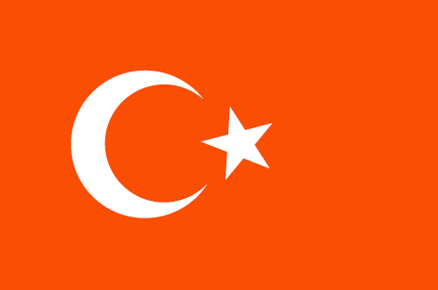

Turkey Portugal Greece
Greece Turkey Portugal
Portugal Greece Turkey

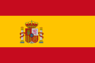
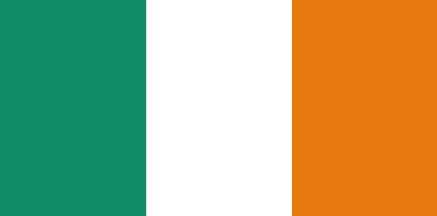
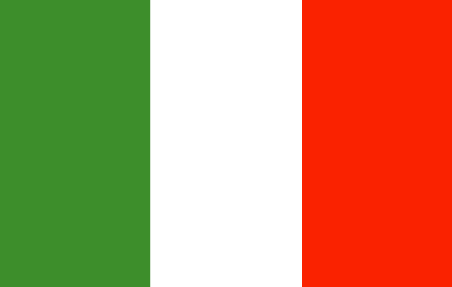

Ireland Italy Spain
Italy Spain Italy
Spain Ireland Ireland

