Name: ____________________________ Surname: ____________________________ N^{ber}: ____ Grade/Class: _____
Assessment: _____________________________ | Date: ___________________________________________________
 | Teacher’s signature:  ___________________________ | Parent’s signature:  ___________________________

Unscramble the country names for each flag
U E T D I N G D K O M I N I D R E L A N G U L A P O R T
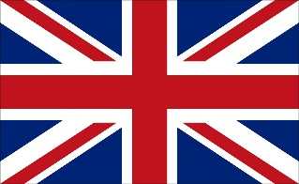
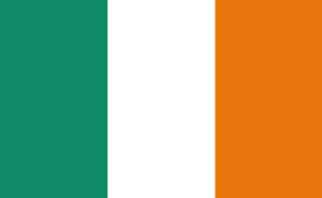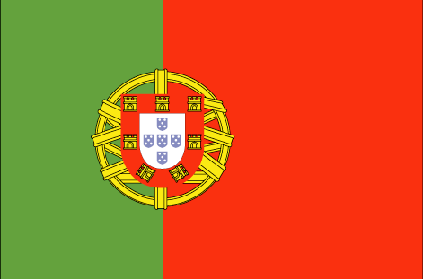
This Photo by Unknown Author is licensed under CC BY-SA
___________________ ___________________ ___________________

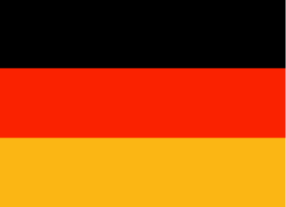
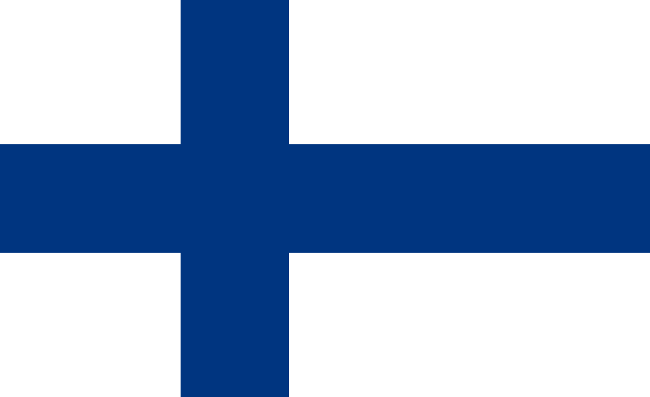
L T A Y I F D N A I L N M A R N G E Y
This Photo by Unknown Author is licensed under CC BY-SA
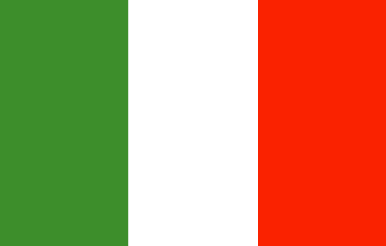
___________________ ___________________ ___________________

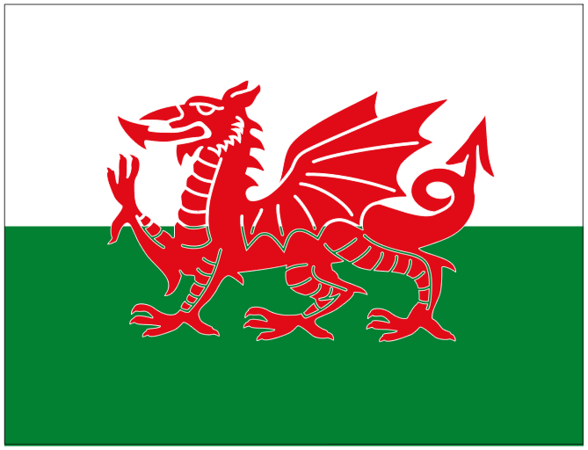
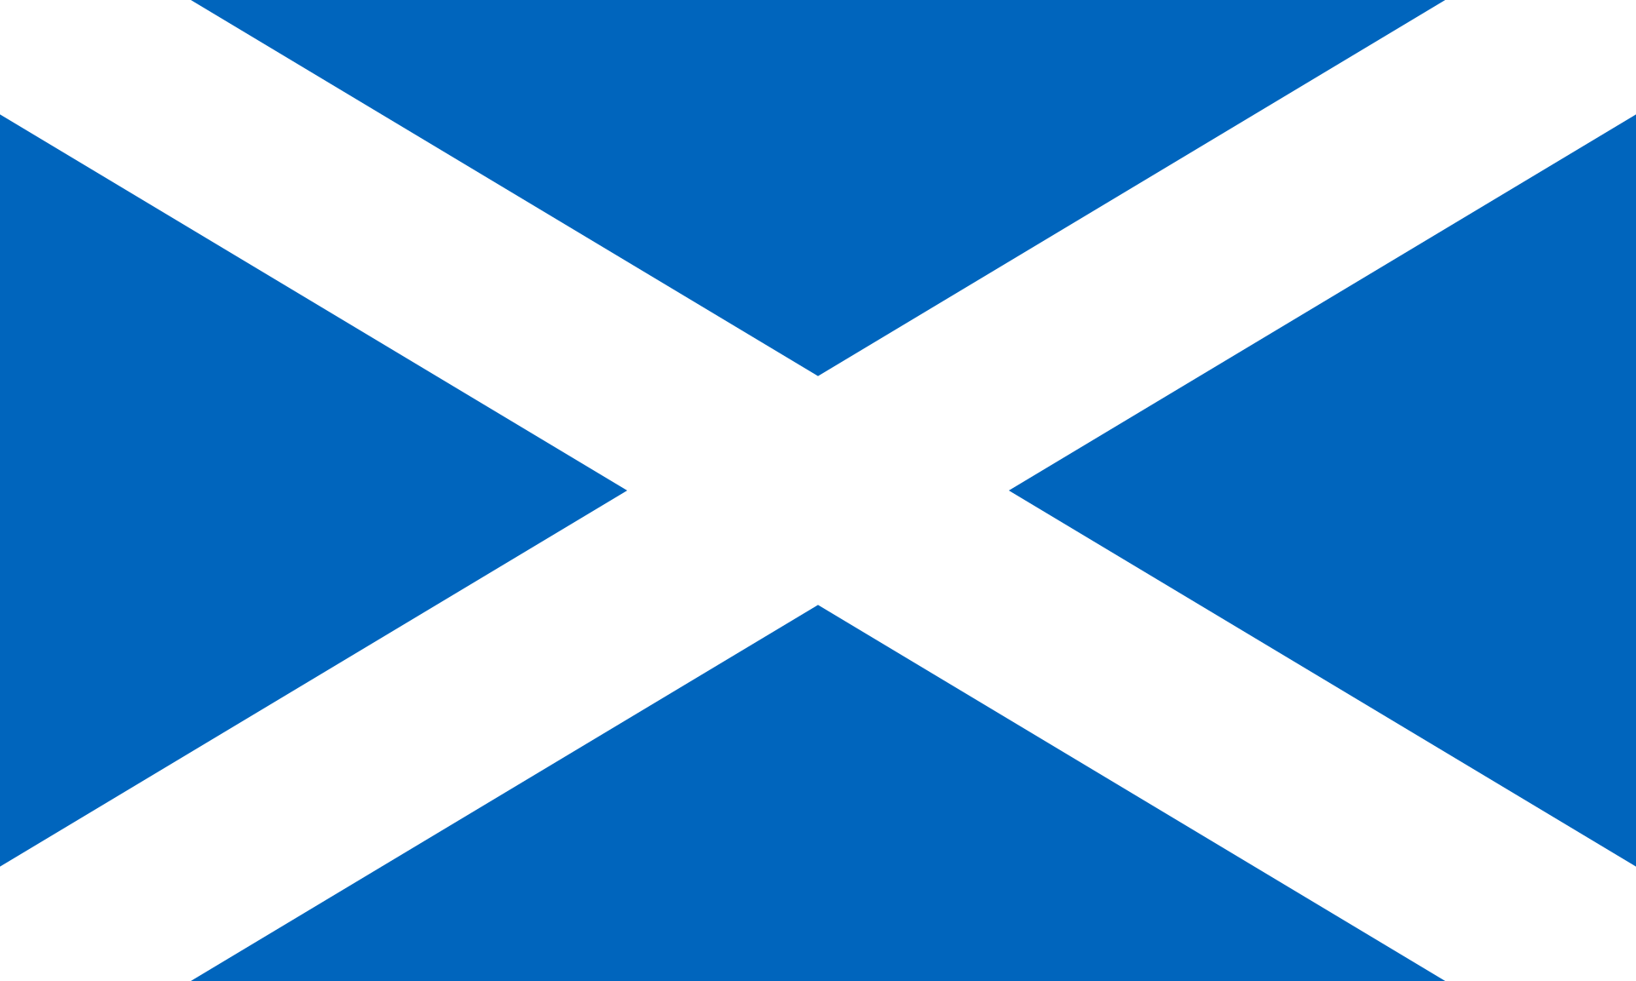
C E R E G E W S E L A S N D A L C T O
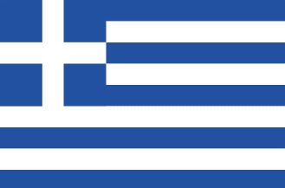
___________________ ___________________ ___________________

Key:
- United Kingdom
- Ireland
- Portugal
- Italy
- Finland
- Germany
- Greece
- Wales
- Scotland

