Name: ____________________________ Surname: ____________________________ N^{ber}: ____ Grade/Class: _____
Assessment: _____________________________ | Date: ___________________________________________________
 | Teacher’s signature:  ___________________________ | Parent’s signature:  ___________________________

- Write and match.
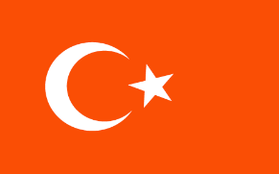
- Gre__ce
- __erma__y
- T__rk__y
- Ir__l__n__
- Sp__i__
- Sw__den
- Eng__ __n__
- Wa__e__
- P__r__u__al
- F__n__and
- Sc__tl__ __d
- __ta__y

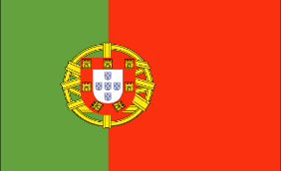

2) Answer.
Where are you from? I am from ___________________

