Name: ____________________________ Surname: ____________________________ N^{ber}: ____ Grade/Class: _____
Assessment: _____________________________ | Date: ___________________________________________________
 | Teacher’s signature:  ___________________________ | Parent’s signature:  ___________________________

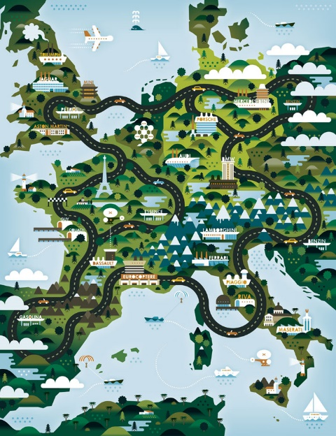
When you read the following names of countries, what is the first thing you think about? Write one or two words for each country.

Turkey ________________________________________________________________
Greece ________________________________________________________________
Portugal ________________________________________________________________
Spain ________________________________________________________________
Italy ________________________________________________________________
Finland ________________________________________________________________
Germany ________________________________________________________________
England ________________________________________________________________
Scotland ________________________________________________________________
Wales ________________________________________________________________
Northern Ireland ________________________________________________________________

