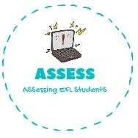ENGLISH WORKSHEET

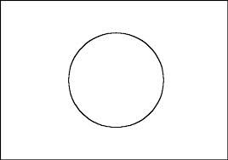

Japan

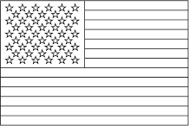

USA

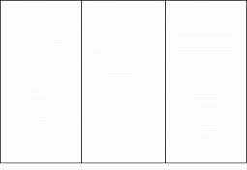

France

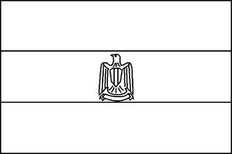

Egypt

|  |  |  |
| --- | --- | --- |
| **TOPIC: Counttries** | **SUBTOPICS: Coloring Flags** | **LEVEL:** |
| **Name: Surname: Nber: Grade/Class:** | | |

|  |  |  |
| --- | --- | --- |
| **CUT** | **GLUE** | **COLOR** |

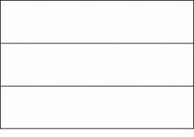

Germany

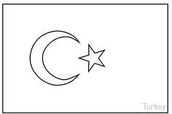

Turkey

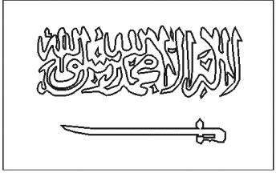

Saudi Arabia

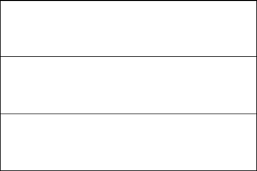

Russia

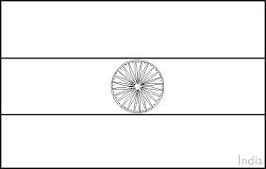

India



Assessing EFL Students