TOPIC: COUNTRIES | SUBTOPICS: NATIONALITIES – VERB CONJUGATION, | LEVEL: A2
Name: Surname: N^{ber}: Grade/Class:

Countries of the World
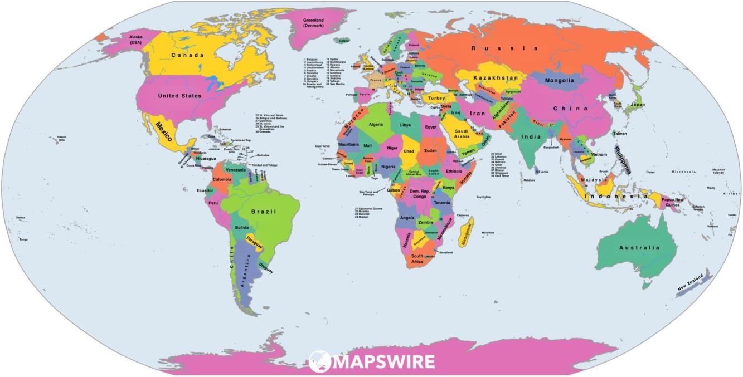
- Draw a line to the country
Germany
Iran
Iraq
China
Japan
Turkey
United Kingdom
Republic of Ireland
South Africa
Ethiopia
Pakistan
Chile
Italy
Agentina
Australia
Spain
New Zealand
Brazil
Greece
Indonesia
Mexico
Portugal
United States of America
Russia
Canada
Finland

Madagascar
Nationalities
Canada Canadian Portugal Portuguese United States of America American Spain Spanish South Africa South African Finland Finnish Australia Australian Germany German New Zealand New Zelander Japan Japanese Republic of Ireland Irish Russia Russian
United Kingdom British Iran Iranian
Turkey Turkish Pakistan Pakistani
Greece Greek Italy Italian

- Fill in the blanks
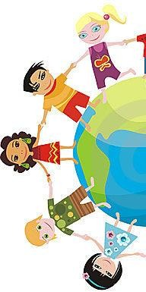
Barbara is from Australia. She is .
Macie is from . She is a New Zealander. Keith is from Canada. He is .
Matti is from . He is Finnish. Maria is from . She is Italian. Marco is from Spain. He is . Yuko is from . She is Japanese. Veli is from Turkey. He is .
Mohamad is from . He is Iranian. Boris is from . He is Russian.
Sunil is from . He is a Pakastani.
Margret is from the United Kingdom (UK). She is . Bob is from the United States of America (USA). He is . Ian is from the republic of Irland. He is .
Helga is from . She is German.

Verbs
Eat Drink Play Fly Go

I | eat | drink | play | fly | go
You | eat | drink | play | fly | go
He/She | eats | drinks | plays | flies | goes
We | eat | drink | play | fly | go
You(all) | eat | drink | play | fly | go
They | eat | drink | play | fly | go

- Fill in the blanks with the verbs above.
In Germany, Helga pretzels. In Russia, Boris soup.

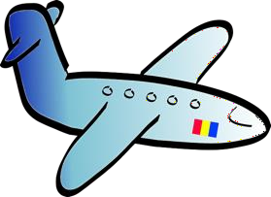
In Pakistan, they tea.
I from Italy to Australia on an aeroplane.
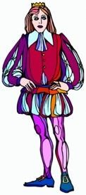
They football in Spain. We to the theatre in the UK.

In the USA they milkshakes.

In Sweden, Ingmarie handball.

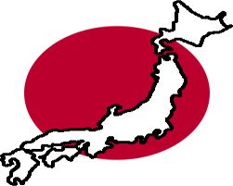
He to the bakery in Finland. She on an aeroplane from Norway to Japan.

