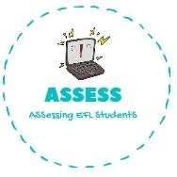
ENGLISH WORKSHEET

TOPIC: COUNTRIES | SUBTOPICS: COUNTRIES | LEVEL: A2
Name: Surname: N^{ber}: Grade/Class:

Countries of the World

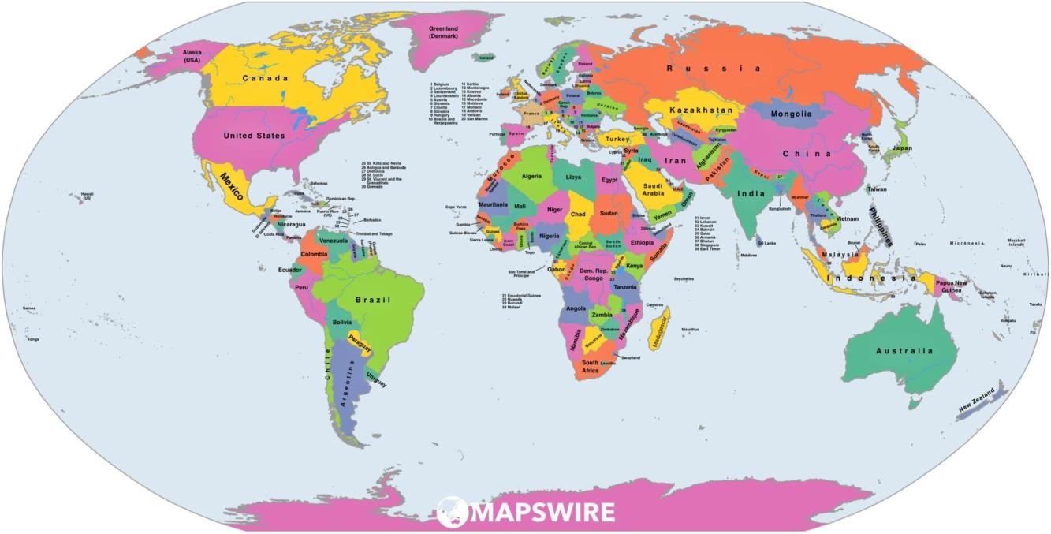
1. Draw a line to the country
United Kingdom
Germany
Iran
Iraq
China
Japan
Turkey
South Africa
Ethiopia
Pakistan
Chile
Italy
Agentina
Australia
Spain
New Zealand
Brazil
Greece
Indonesia
Mexico
Portugal
United States of America
Russia
Canada
Finland

Republic of Ireland

Madagascar

Assessing EFL Students

