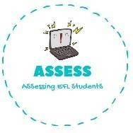
ENGLISH WORKSHEET
Assessing EFL Students

TOPIC: Countries | SUBTOPICS: Label the country | LEVEL: A2
Name: Surname: N^{ber}: Grade/Class:

