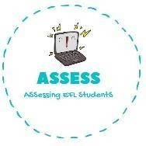
ENGLISH WORKSHEET
Assessing EFL Students

TOPIC: Flags | SUBTOPICS: Label the pictures | LEVEL: A2
Name: Surname: N^{ber}: Grade/Class:

Ireland / Greece / Russia / Australia / Finland / South Africa / United States of America / Sweden / Iraq / Iran / Turkey / United Kingdom / Portugal / Italy / Germany / Spain

