Name: ____________________________ Surname: ____________________________ N^{ber}: ____ Grade/Class: _____
Assessment: _____________________________ | Date: ___________________________________________________
 | Teacher’s signature:  ___________________________ | Parent’s signature:  ___________________________

Listen to the story write the name and country next to the child and color.

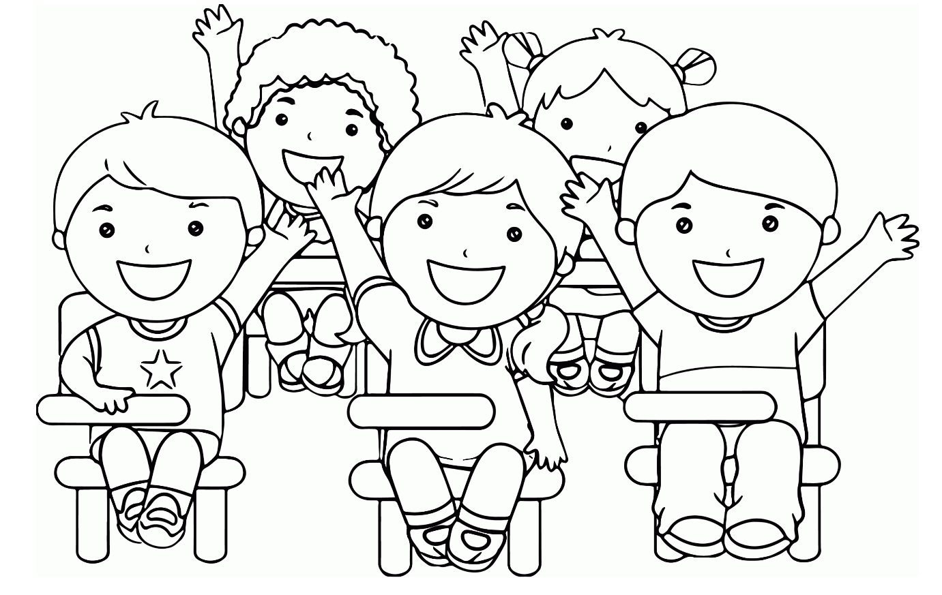

Transcript:
Sam is from England. He is sitting in the front row and has both hands up in the air. Color Sam’s pants green.
Behind Sam is Lisa. She is from Germany. Color Lisa’s hair yellow.
Next to Lisa is David. He is from Scotland. Color David’s hair red.
Tina is sitting in the middle between Sam and George. Tina is from Spain. Color Tina’s dress pink.
George is sitting next to Tina. George is from Italy. Color George’s shirt blue.

