Name: ____________________________ Surname: ____________________________ N^{ber}: ____ Grade/Class: _____
Assessment: _____________________________ | Date: ___________________________________________________
 | Teacher’s signature:  ___________________________ | Parent’s signature:  ___________________________

- Listen and number the countries.

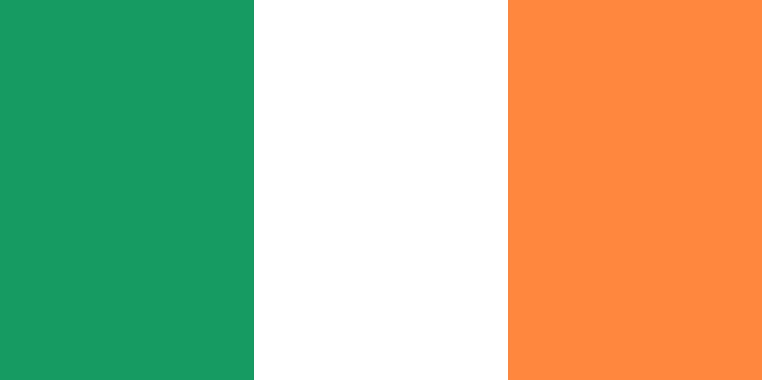
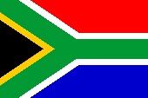
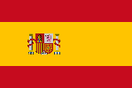
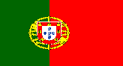
This Photo by Unknown Author is licensed under CC BY-SA

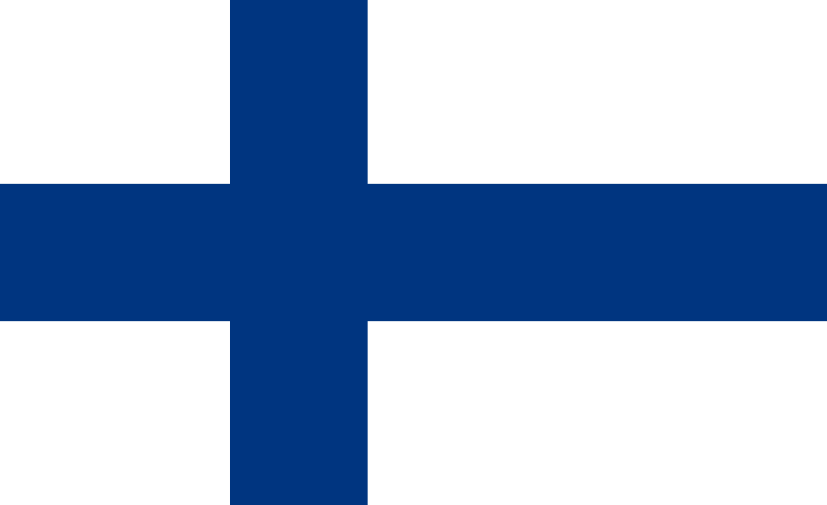
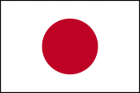
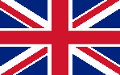
This Photo by Unknown Author is licensed under CC BY-SA
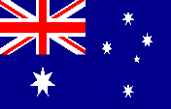

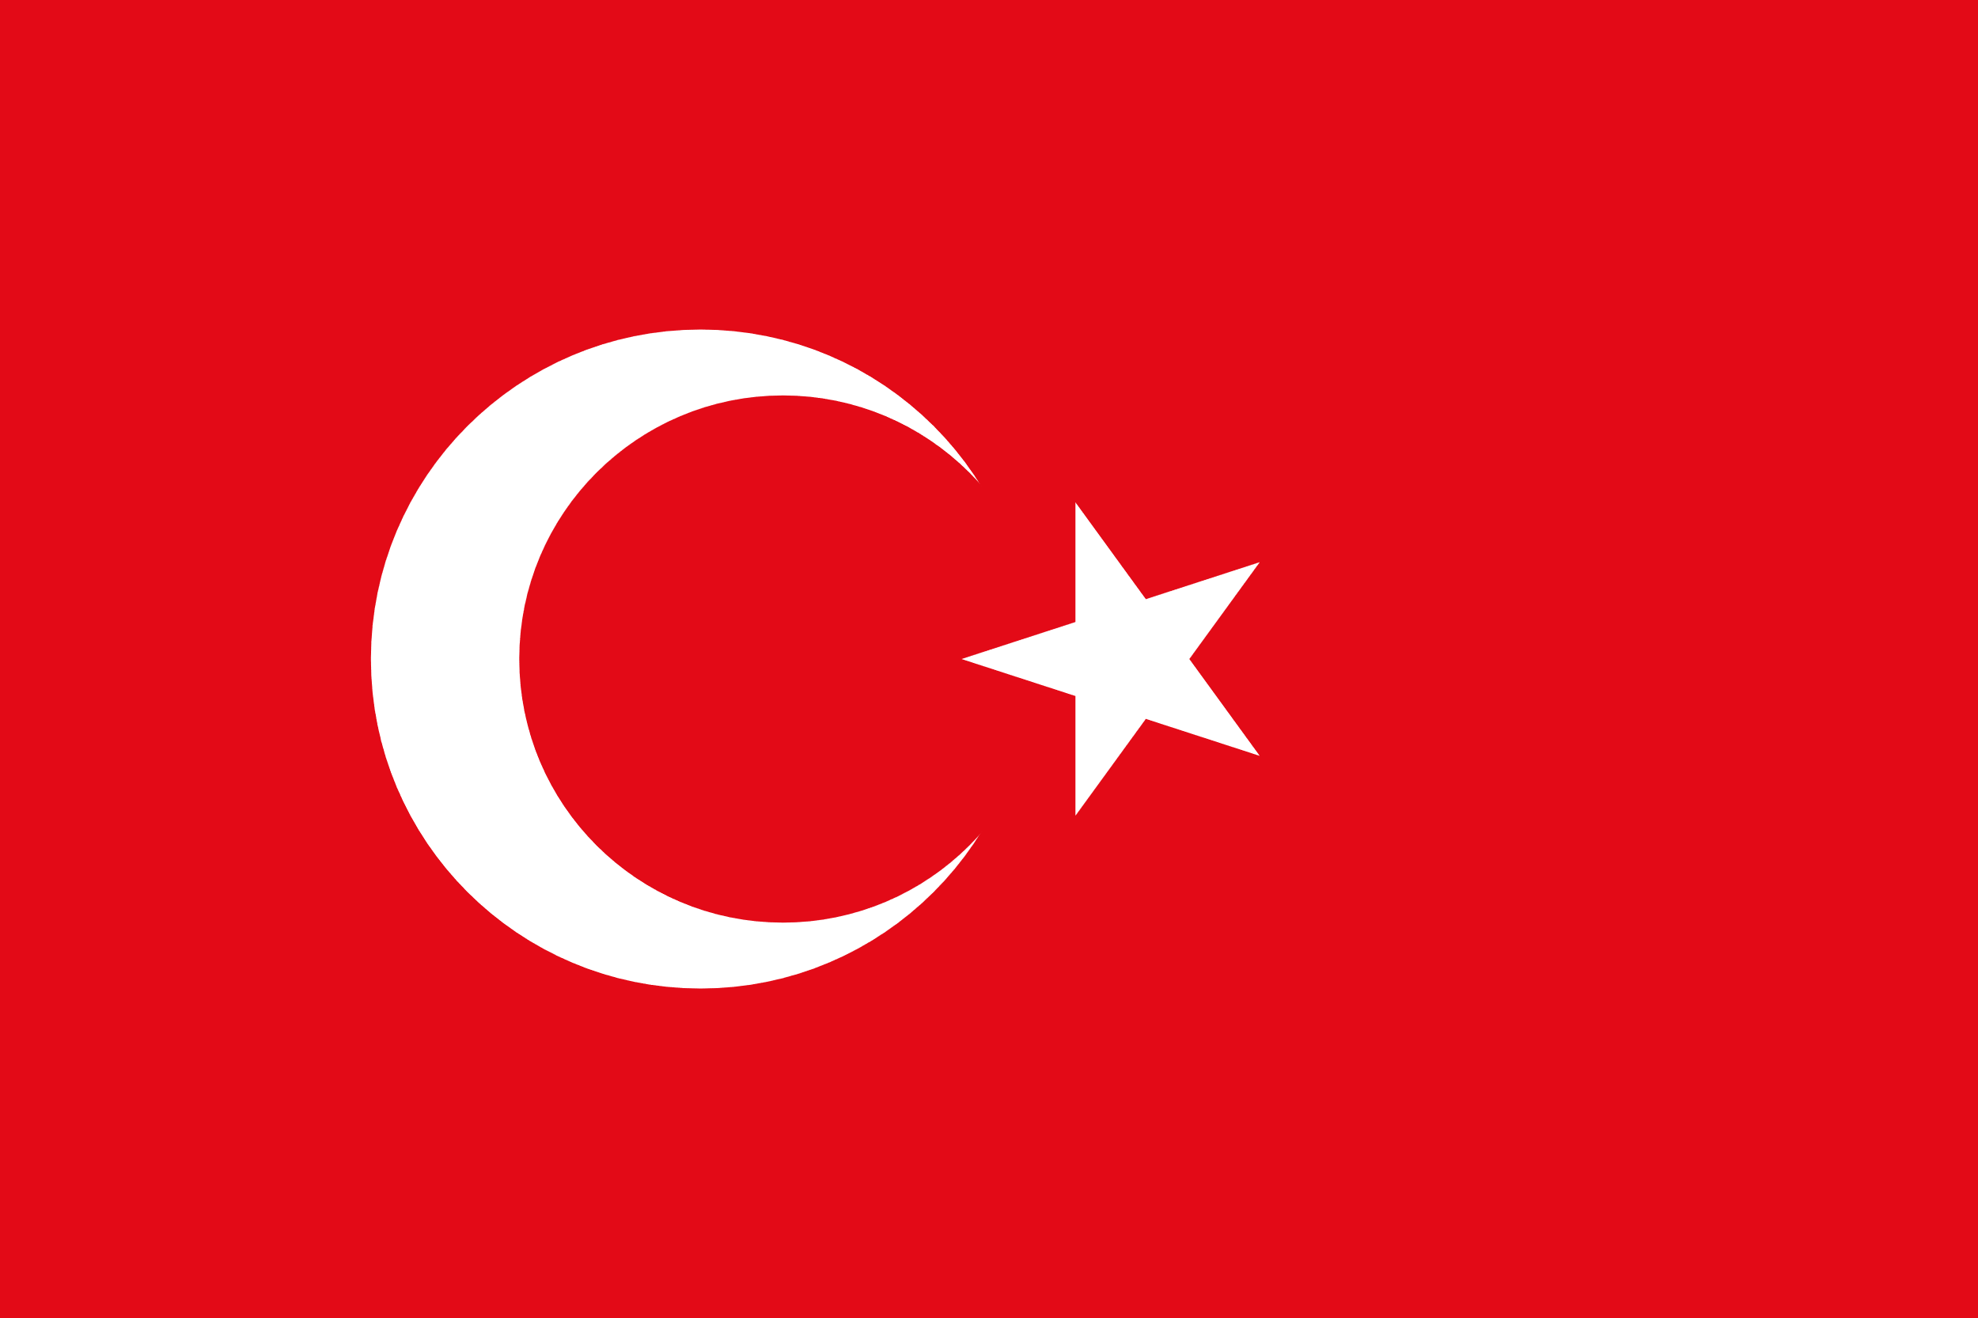
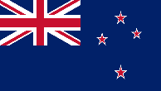
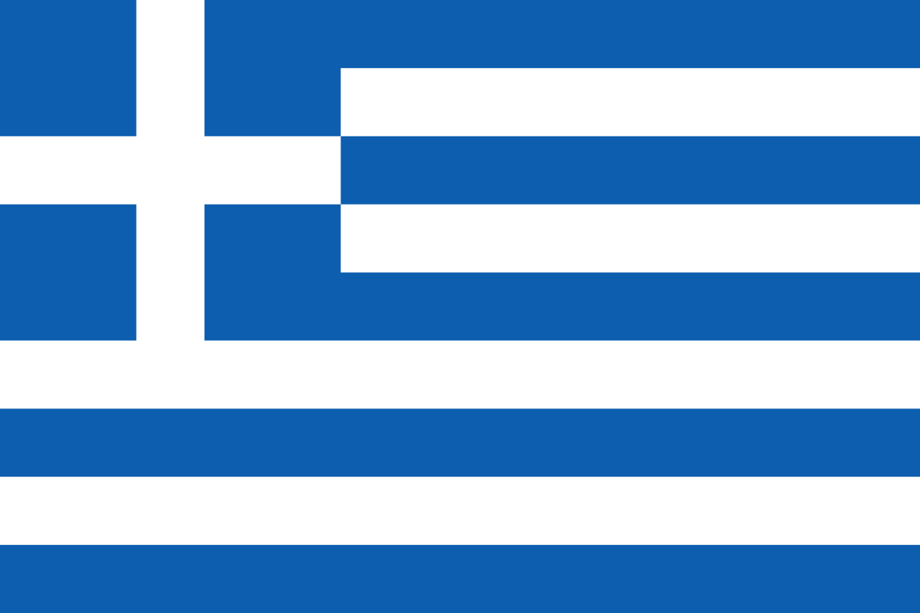

- Listen and colour.
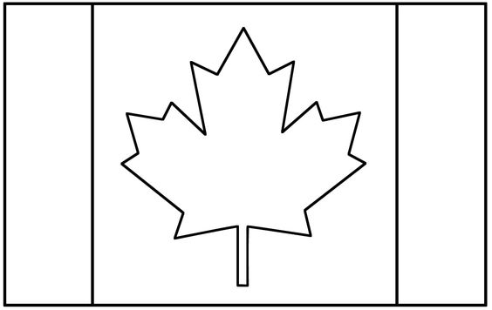

Transcript 1:

- Number one is South Africa
- Number two is Portugal
- Number three is Japan
- Number four is Spain
- Number five is the United Kingdom
- Number six is Australia
- Number seven is Turkey
- Number eight is Iraq
- Number nine is Greece
- Number ten is New Zealand
- Number eleven is Ireland
- Number twelve is Finland

Transcript 2:

This is the flag of Canada. It has only two colors. Red and white.
Color the leaf in the middle red, and then color the boxes eather side of the leaf also red.
Now you know how the Canadian flag looks like.

