Name: ____________________________ Surname: ____________________________ N^{ber}: ____ Grade/Class: _____
Assessment: _____________________________ | Date: ___________________________________________________
 | Teacher’s signature:  ___________________________ | Parent’s signature:  ___________________________

Listen and circle yes or no.
2
3
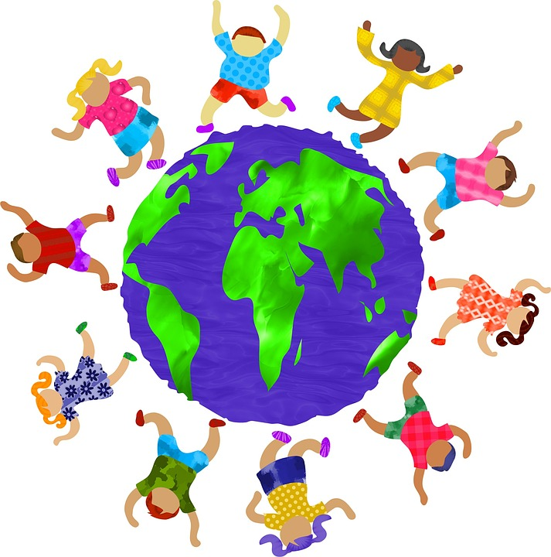
1

4

10

5

9
6

8
7

- Finland YES / NO 2. Italy YES / NO 3. England YES / NO
4. Wales YES / NO 5. Finland YES / NO 6. Spain YES / NO
7. Scotland YES / NO 8. Turkey YES / NO 9. Italy YES / NO
10. Portugal YES / NO

Transcript:
- The girl with the pink shirt is from Germany.
- The boy with the red shorts is from Italy.
- The girl in the yellow dress is from England.
- The boy in the pink shirt is from Wales
- The girl in the red dress is from Finland
- The boy in the green shorts is from Northern Ireland.
- The girl with the purple hair is from Scotland
- The boy with the green shirt is from Turkey
- The girl with the purple dress is from Portugal.
- The boy in the red shirt is from Spain.

Key:
- The girl with the pink shirt is from Germany. (NO)
- The boy with the red shorts is from Italy. (YES)
- The girl in the yellow dress is from England. (YES)
- The boy in the pink shirt is from Wales (YES)
- The girl in the red dress is from Finland (YES)
- The boy in the green shorts is from Northern Ireland. (NO)
- The girl with the purple hair is from Scotland (YES)
- The boy with the green shirt is from Turkey (NO)
- The girl with the purple dress is from Portugal. (NO)
- The boy in the red shirt is from Spain. (NO)

