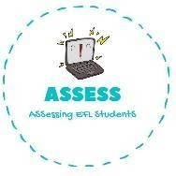
ENGLISH WORKSHEET

TOPIC: Flags | SUBTOPICS: Match the flag | LEVEL: A2
Name: Surname: N^{ber}: Grade/Class:

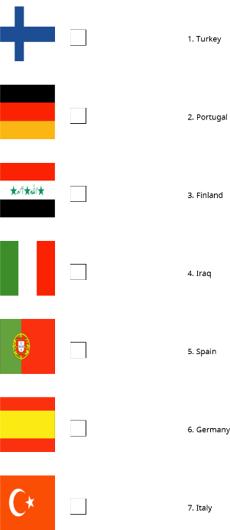

Assessing EFL Students

