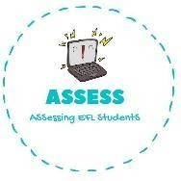
ENGLISH WORKSHEET

TOPIC: Flags | SUBTOPICS: Multiple choice | LEVEL: A2
Name: Surname: N^{ber}: Grade/Class:

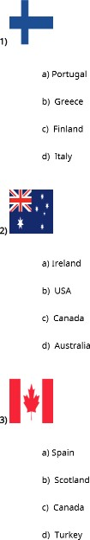
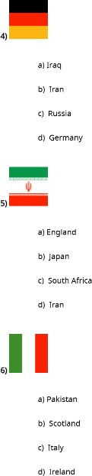
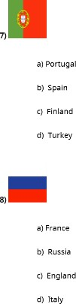

Assessing EFL Students

