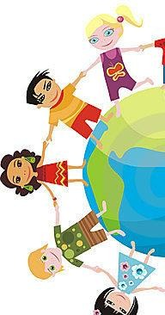
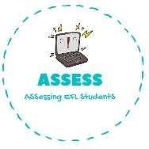
ENGLISH WORKSHEET
TOPIC: COUNTRIES
SUBTOPICS: COUNTRIES
LEVEL: A2

TOPIC: COUNTRIES | SUBTOPICS: NATIONALITIES – ARTICLES | LEVEL: A2
Name: Surname: N^{ber}: Grade/Class:

Nationalities

Canada | Canadian | Portugal | Portuguese
United States of America | American | Spain | Spanish
South Africa | South African | Finland | Finnish
Australia | Australian | Germany | German
New Zealand | New Zelander | Japan | Japanese
Republic of Ireland | Irish | Russia | Russian
United Kingdom | British | Iran | Iranian
Turkey | Turkish | Pakistan | Pakistani
Greece | Greek | Italy | Italian

Fill in the blanks
Barbara is from Australia. She is .
Macie is from . She is a New Zealander. Keith is from Canada. He is .
Matti is from . He is Finnish. Maria is from . She is Italian. Marco is from Spain. He is . Yuko is from . She is Japanese. Veli is from Turkey. He is .
Mohamad is from . He is Iranian. Boris is from . He is Russian.
Sunil is from . He is a Pakastani.
Margret is from the United Kingdom (UK). She is . Bob is from the United States of America (USA). He is . Ian is from the republic of Irland. He is .
Helga is from . She is German

Assessing EFL Students

