Name: ____________________________ Surname: ____________________________ N^{ber}: ____ Grade/Class: _____
Assessment: _____________________________ | Date: ___________________________________________________
 | Teacher’s signature:  ___________________________ | Parent’s signature:  ___________________________

Read the text and answer the questions.
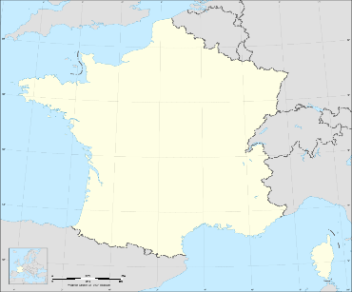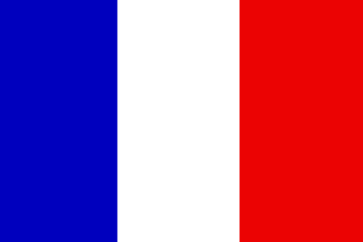
This Photo by Unknown Author is licensed under CC BY-SA

This is France. People who are from France are French.
Paris is the capital city of France. The Eiffel Tower is in Paris. The French flag has three colours. Blue, white and red.
France has 7 neighbors. Spain, Switzerland, Italy, Belgium, Luxembourg and Andorra.
They speak French in France and Luxembourg. In Belgium they speak French and Flemish.
In Andorra they speak Catalan, Spanish and French. In Italy they speak Italian. In Switzerland they speak German, French, Italian and Romansh.

What is the capital of France? ___________________________________________________
What famous building is in Paris? ___________________________________________________
How many neighbours does France have? ___________________________________________________
What languages do they speak in Belgium? ___________________________________________________
What are people from France called? ___________________________________________________
What are the colours of the French flag? ___________________________________________________

