Name: ____________________________ Surname: ____________________________ N^{ber}: ____ Grade/Class: _____
Assessment: _____________________________ | Date: ___________________________________________________
 | Teacher’s signature:  ___________________________ | Parent’s signature:  ___________________________

Match the countries where English is spoken with the correct flag.

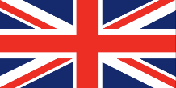
A

B

C

D

E

F

G

Canada

1)

Australia
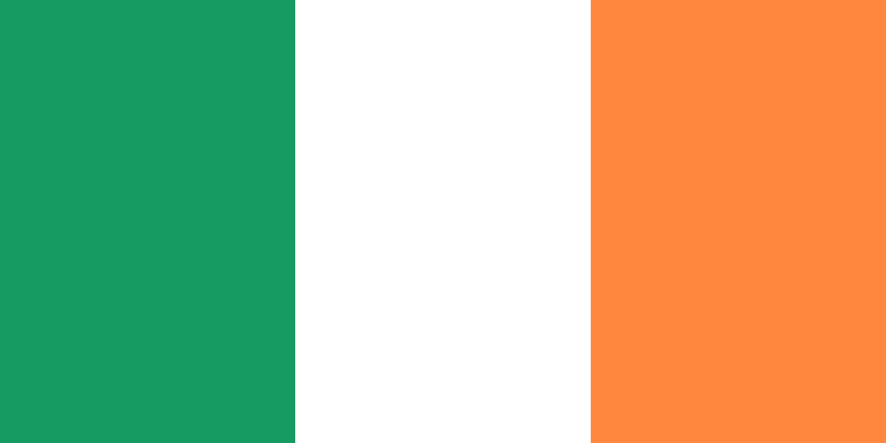

2)

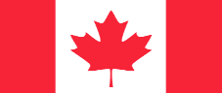

South Africa

3)

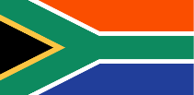

United States of America

4)

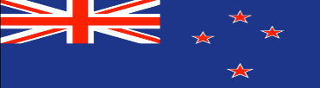

New Zealand

5)

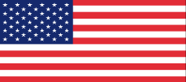

United Kingdom

6)

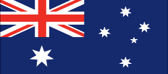
7)

Ireland

