|  |  |  |
| --- | --- | --- |
| **Name:** ____________________________ **Surname:** ____________________________ **Nber: ____ Grade/Class:** _____ | | |
| **Assessment:** _____________________________ | **Date:** ___________________________________________________ | |
| **Teacher’s signature:**  **___________________________** | **Parent’s signature:**  **___________________________** |

**Read and answer the questions.**

**TURKEY-MEHMET OKUR GREECE-SOCRATES**

Where is Mehmet Okur from?

______________________

What nationality is he?

______________________

Where is Elvis Presley From?

______________________

What nationality is he?

______________________

Where is Yoko Ono from?

______________________

What nationality is she?

______________________

Where is Pablo Picasso from?

______________________

What nationality is he?

______________________

Where is Leonardo da Vinci from?

______________________

What nationality is he?

______________________

Where is Socrates from?

______________________

What nationality is he?

______________________

Where is Elton John from?

______________________

What nationality is he?

______________________

Where is Vladimir Putin from?

______________________

What nationality is he?

______________________

Where is Kimi Räikkönen from?

______________________

What nationality is he?

______________________

Where is Cristiano Ronaldo from?

______________________

What nationality is he?

______________________

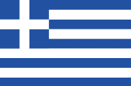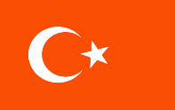

**USA-ELVIS PRESLEY UNITED KINGDOM-ELTON JOHN**

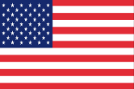

**JAPAN-YOKO ONO RUSSIA-VLADIMIR PUTIN**

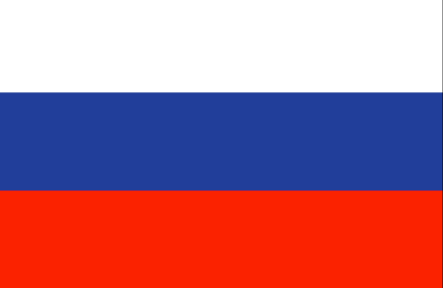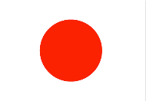

**SPAIN-PABLO PICASSO FINLAND-KIMI RÄIKKÖNEN**

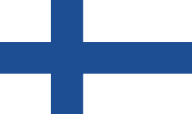[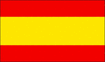](http://schools.clipart.com/search/close-up?oid=2708911&q=spain%20flag&s=1&a=c&cid=&fic=)

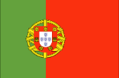**ITALY-LEONARDO DA VINCI PORTUGAL-CRISTIANO RONALDO**

