Name: ____________________________ Surname: ____________________________ N^{ber}: ____ Grade/Class: _____
Assessment: _____________________________ | Date: ___________________________________________________
 | Teacher’s signature:  ___________________________ | Parent’s signature:  ___________________________
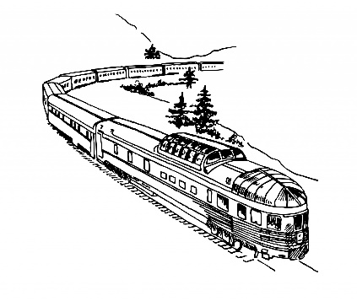
Read the text and answer with true or false.

Jane is happy today. She is travelling to Scotland today. She is going on holiday with her family. She lives in London where she goes to school.
She is travelling by train through the country. Jane is talking to her parents about the things they are going to do together on their holiday. They are staying at a hotel near the castle. They are going to visit the castle one day, go to the beach and go for walks in the city. Jane has never been to Scotland before. She wants to try some Scottish food.
Scotland is up in the north of the United Kingdom. The people in Scotland are called Scots.

Jane is unhappy today. TRUE / FALSE
She is travelling to Scotland. TRUE / FALSE
They are travelling by train. TRUE / FALSE
They will stay in an apartment. TRUE / FALSE
Jane has been to Scotland before. TRUE / FALSE
Scotland is in the United Kingdom. TRUE / FALSE

