Name: ____________________________ Surname: ____________________________ N^{ber}: ____ Grade/Class: _____
Assessment: _____________________________ | Date: ___________________________________________________
 | Teacher’s signature:  ___________________________ | Parent’s signature:  ___________________________

Talk about the flags and describe what they look like. What is the nationality of the people from that country? Fill in X or O in the table.
- What the flag looks like.
- What nationality they are
Example: 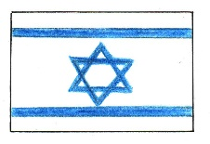
This is the flag of Israel. The flag has a white background. There is a blue star in the middle of the flag. There are two blue stripes above and below the star. The people from Israel are called Israelis.
Flags | Canada | Italy | Spain | France | Portugal | Turkey | Greece
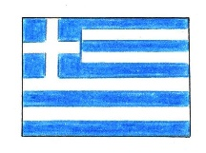 |  |  | O |  |  |  | X
