Name: ____________________________ Surname: ____________________________ N^{ber}: ____ Grade/Class: _____
Assessment: _____________________________ | Date: ___________________________________________________
 | Teacher’s signature:  ___________________________ | Parent’s signature:  ___________________________

Pair work. Ask your friend questions. The swap with your friend and answer questions.
Pretend you are from another country. Choose from any of the following countries:
South Africa, United Kingdom, Canada, Australia, United States of America, Japan, Iran, Iraq and Russia

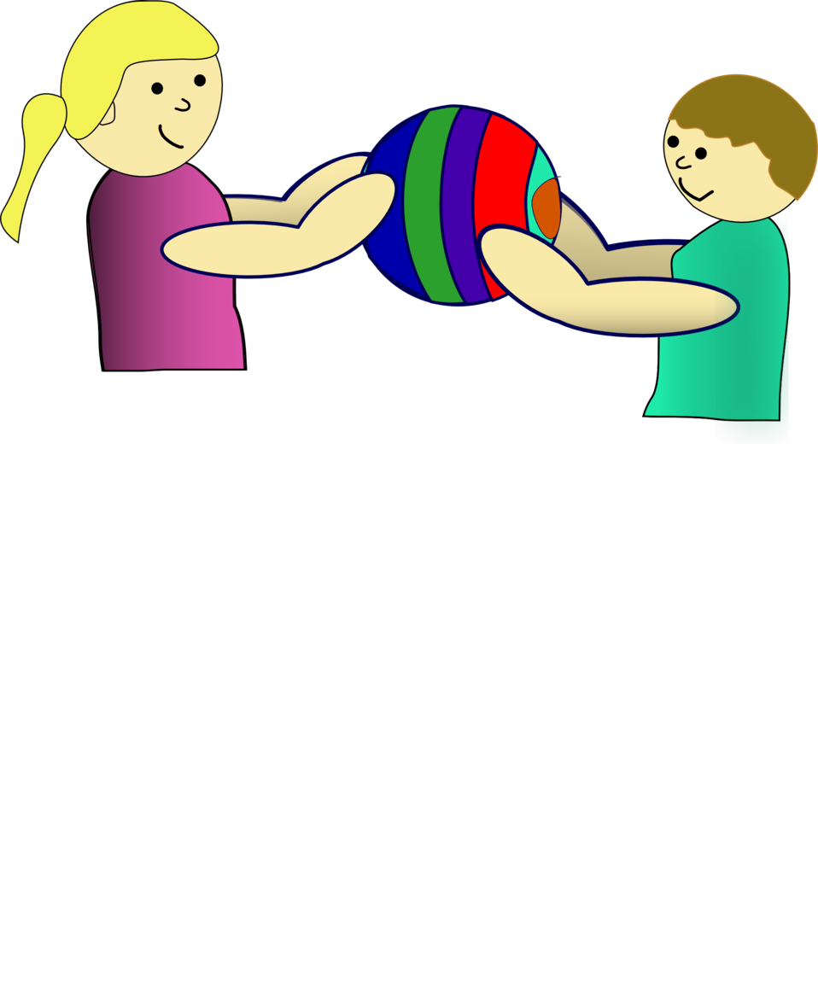

What is your name?
What country you are from?
What city do you live in?
What is your nationality?
What you do when you are not in school?
How the weather is in your country in the winter?
What languages do you speak?
Where you would like to travel on holiday?
What is your favorite country?

