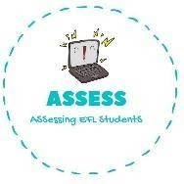
ENGLISH WORKSHEET

TOPIC: Flags | SUBTOPICS: True or false | LEVEL: A2
Name: Surname: N^{ber}: Grade/Class:

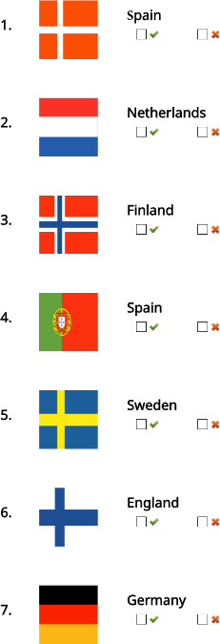
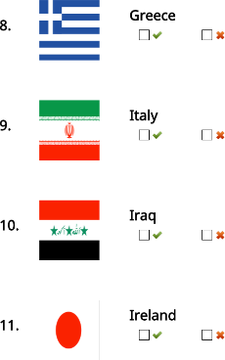

Assessing EFL Students

